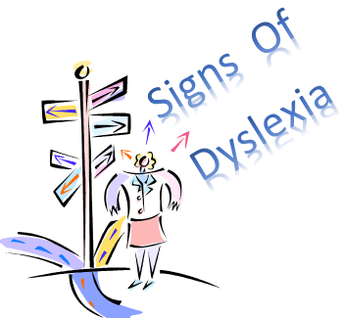
Signs Your Child may be Dyslexic in Secondary School
General Signs
- Your child will often have problems being organised with homework assignments and deadlines.
- They often feel they have to work extra hard to keep up.
- They will find it difficult to recall facts learnt between lessons
- Class ability is considered to be higher than is shown in tests
- Prefers to learn with a ‘hands on’ approach.
- Uses a lot of avoidance techniques. Being really quiet, or misbehaving.
Writing –
- Good at ideas – but unable to transfer them to paper
- Writes easier words and concepts than they can express.
- Very slow to finish written work, or rarely completes it.
- Unable to sequence ideas
- Poor handwriting
- Finds copying from the board difficult

Reading
- Slow to process reading material, and has to repeatedly re-read it to understand it.
- Often reluctant to read.
- May pick books that are too difficult to disguise their problems and maintain self esteem.

