**How to make the most of MS Word 2007**

1. **Quick access toolbar**

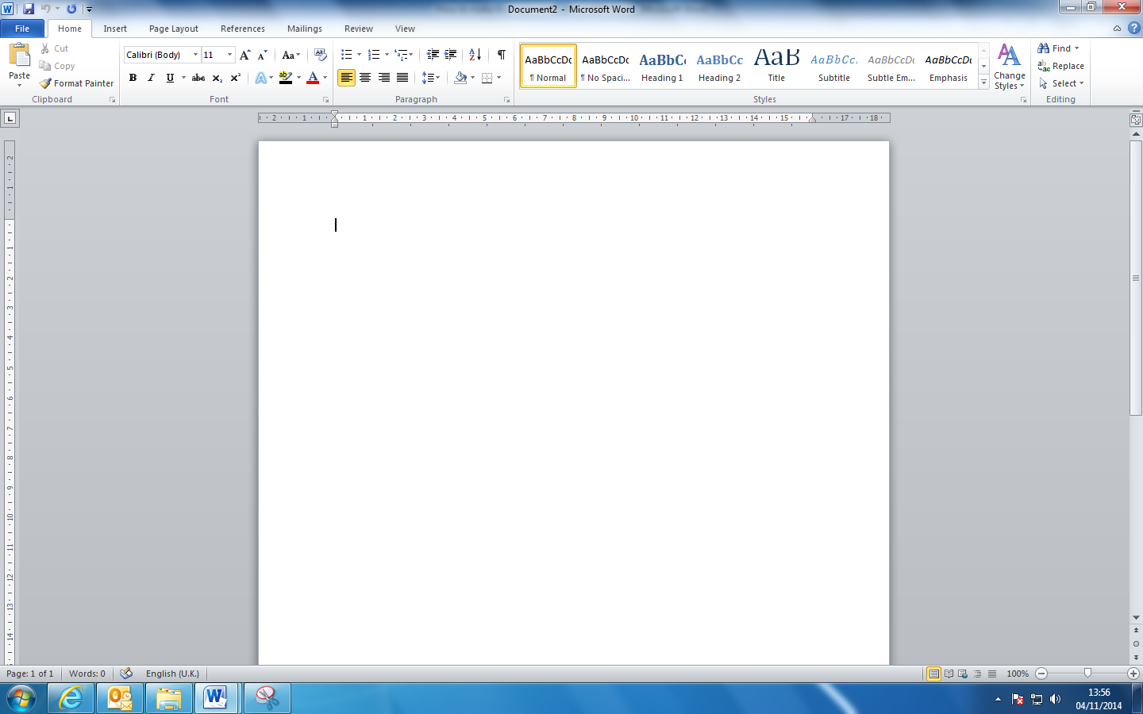

Click on the expand button. Click on ‘more commands’. Under ‘choose commands from’ select ‘all commands’. You will then get a list of all the functions available in Word. Select the ones you use a lot and want to be available in one click and when you start up a word document.

**2. Undo**



‘Undo’ is very useful to get back to a stage in a piece of writing where it still made sense. It also allows things that have miraculously disappeared to reappear.

1. 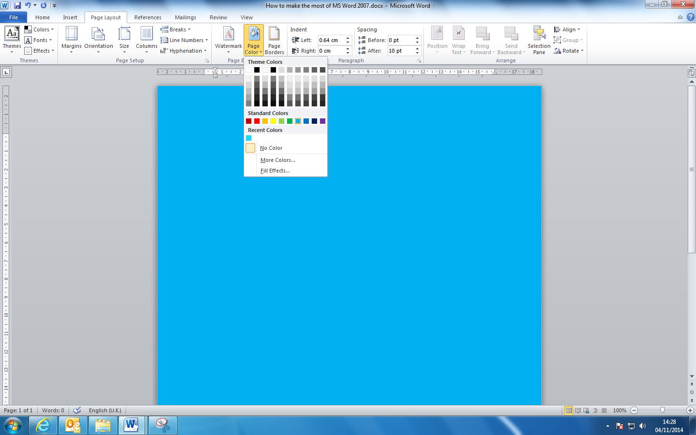**Page colour**

Click on ‘Page Layout’. Then select page colour. This allows you to customise the background colour of any document.

1. **Distance between lines**

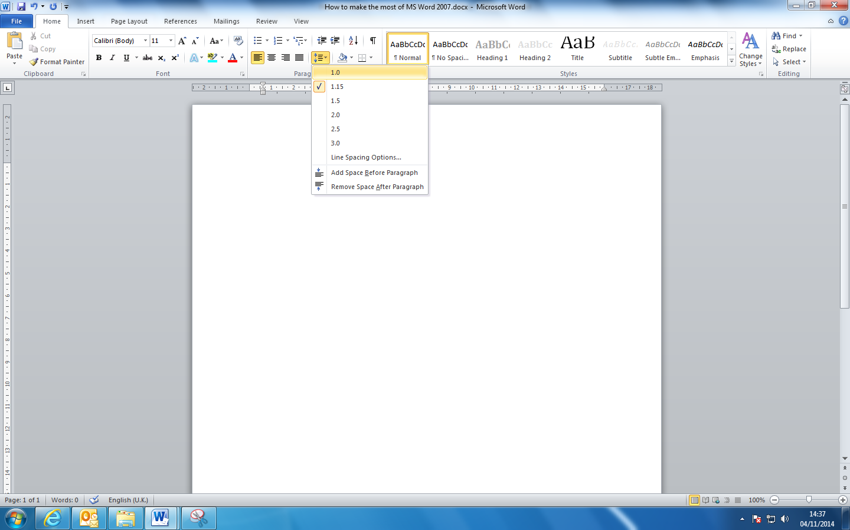Click on the ‘Home’ tab. In the paragraph section select the distance between lines you require.

1. **Text to speech**

Click on the expand button as for section 1. Find ‘speak’ under ‘all commands’ and add it to your quick access toolbar.

1. **To hide everything except the quick access toolbar**

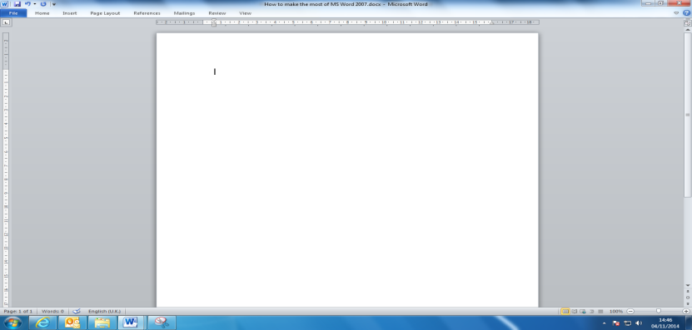

Press Fn and F1 or Ctrl and F1 at the same time.

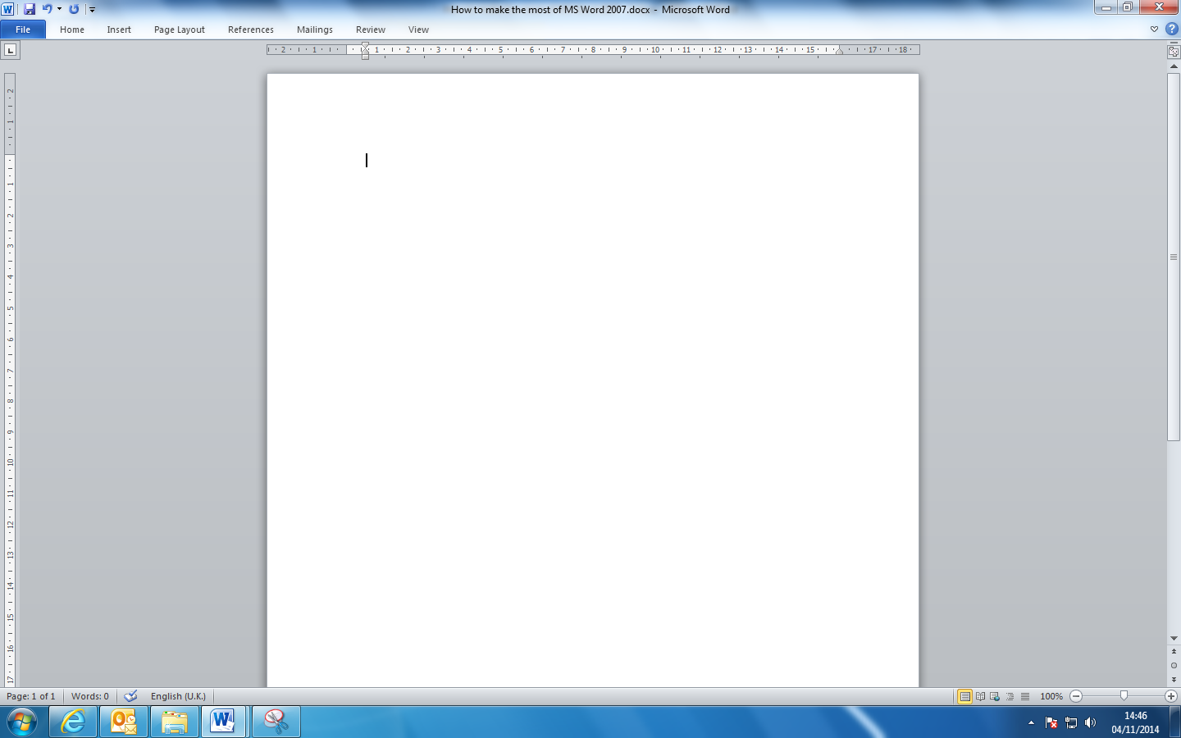 Click here to unhide

1. **SmartArt for mind maps**

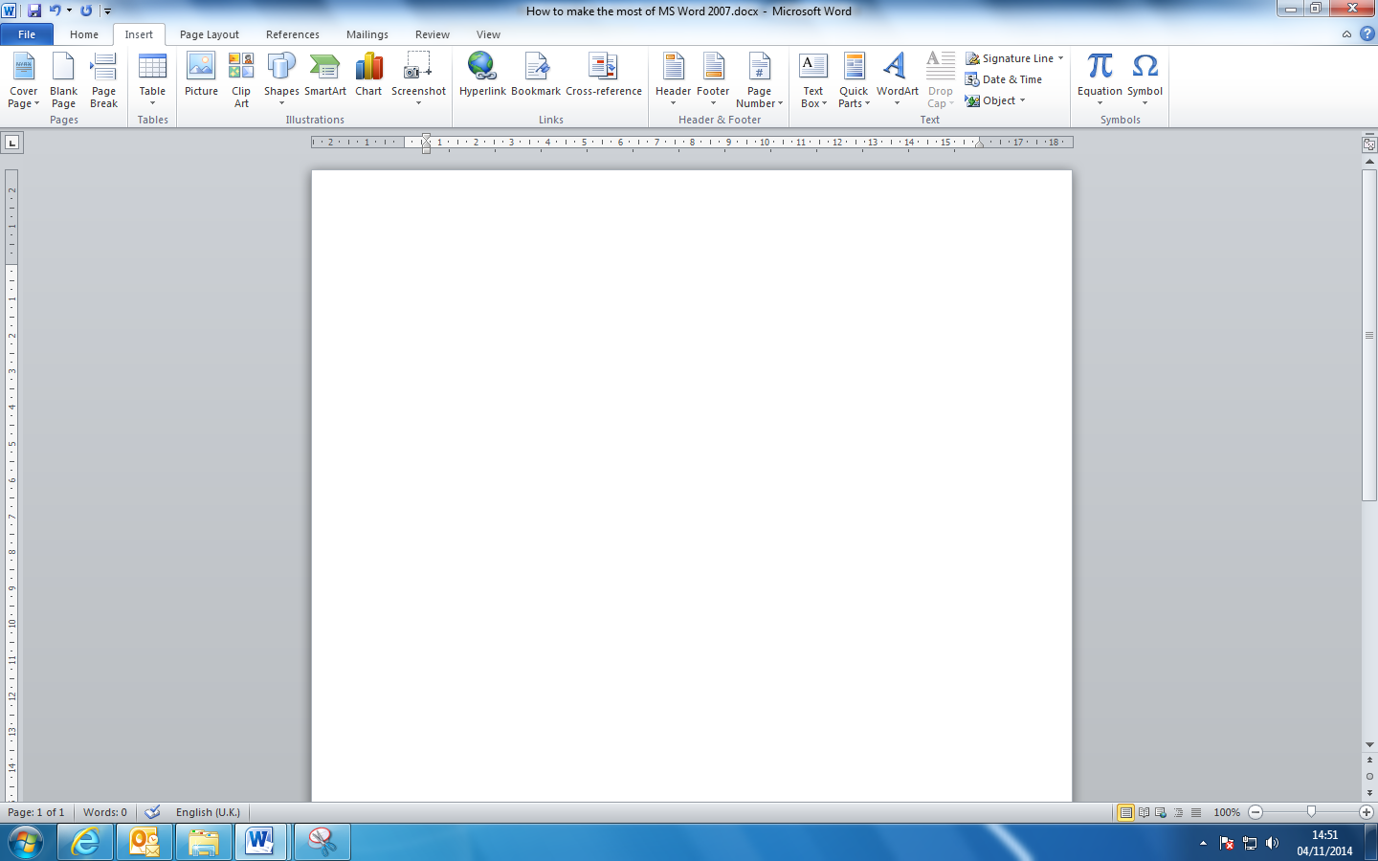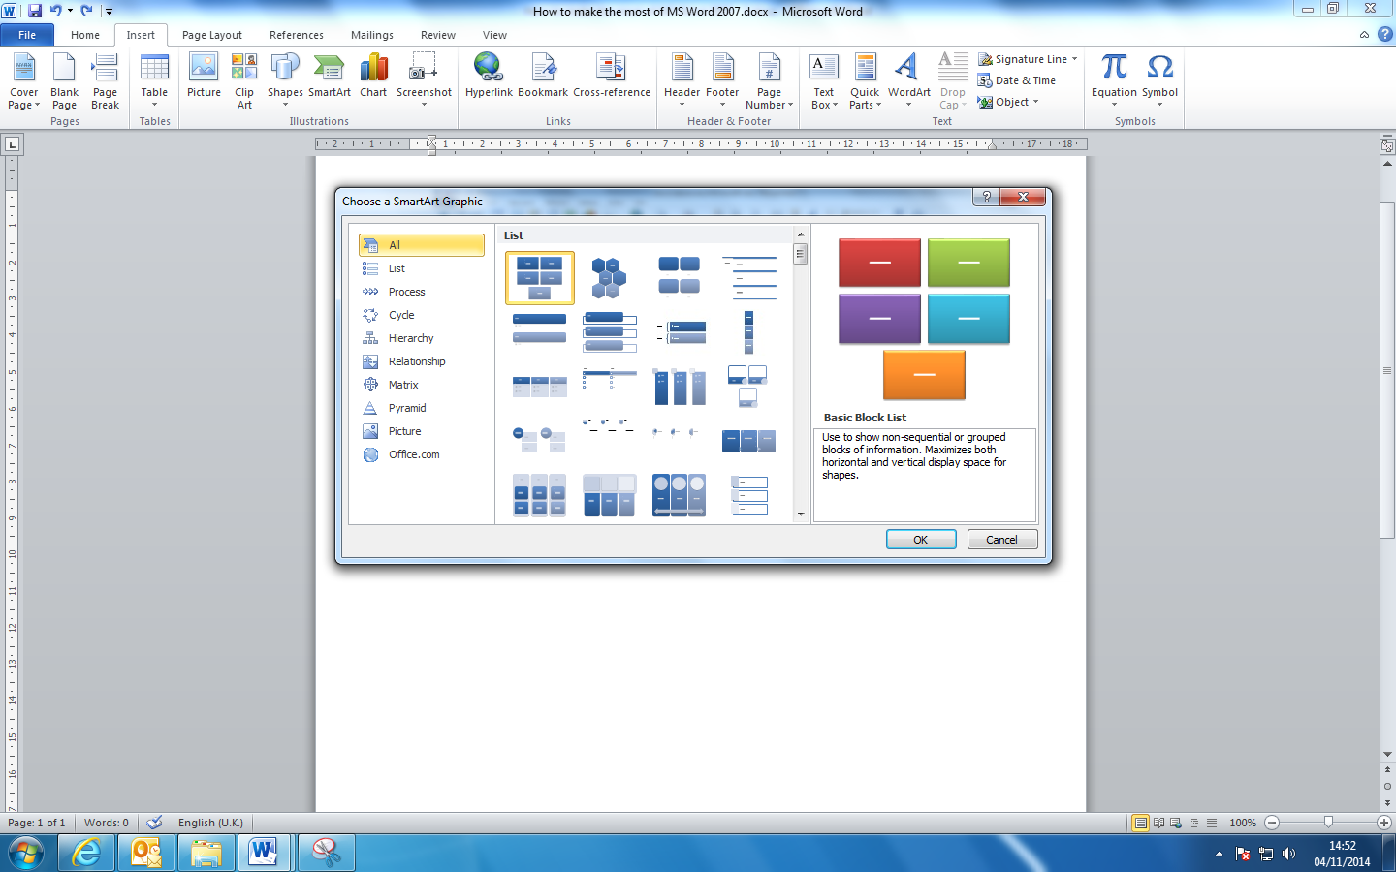

1. **Checking readability**

In a word document click on ‘File’ and select ‘Options’. Select ‘Proofing’.

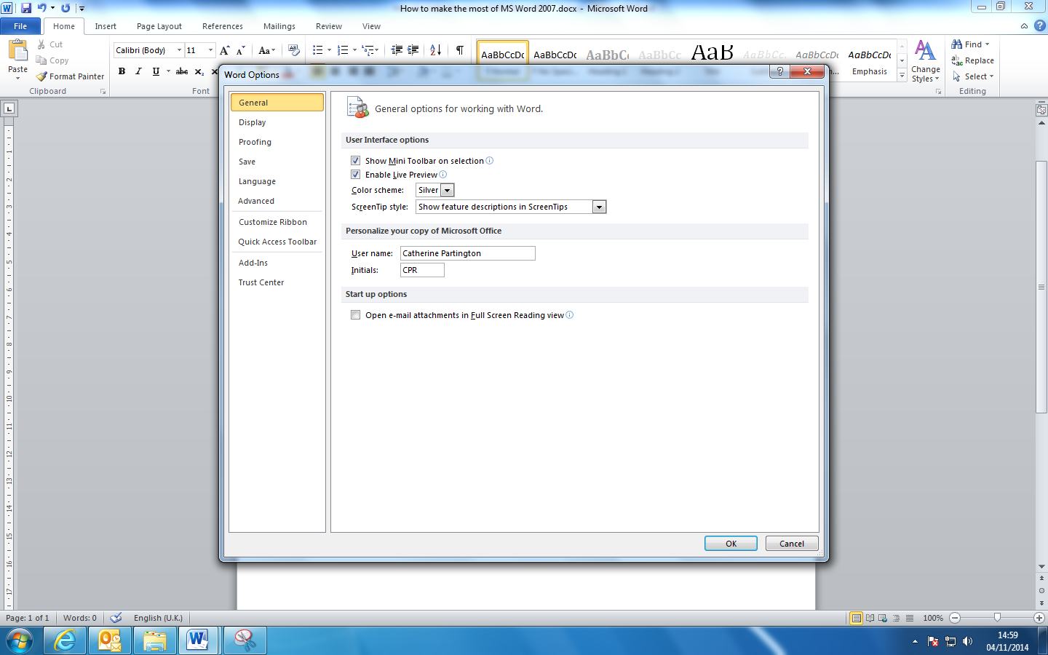

**Click on ‘readability statistics’**

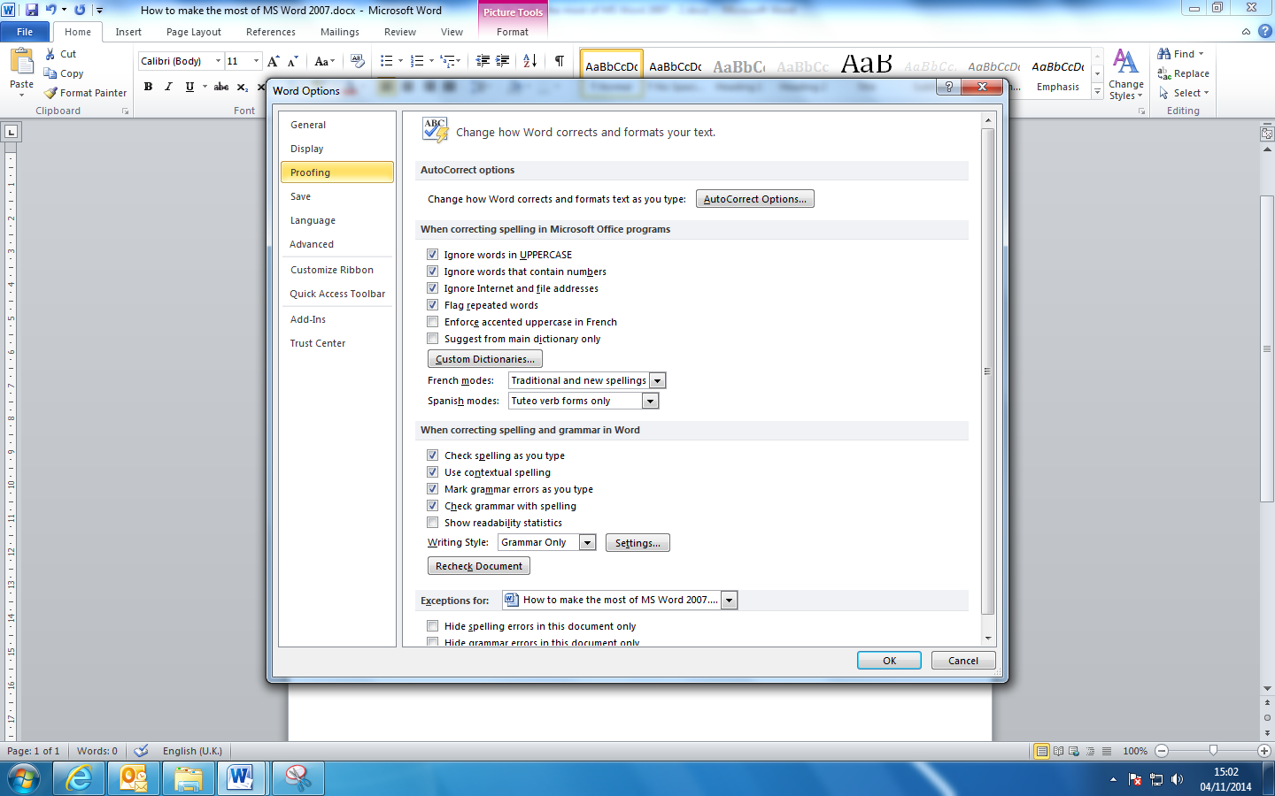

1. **Replace**

Use ‘Replace’ to correct spelling mistakes made regularly. Click on ‘Replace’, type the *wrong*  spelling into ‘find what’ and the *correct* spelling into ‘replace with’. You can also use this for typing in shorthand, for example ‘intl’.

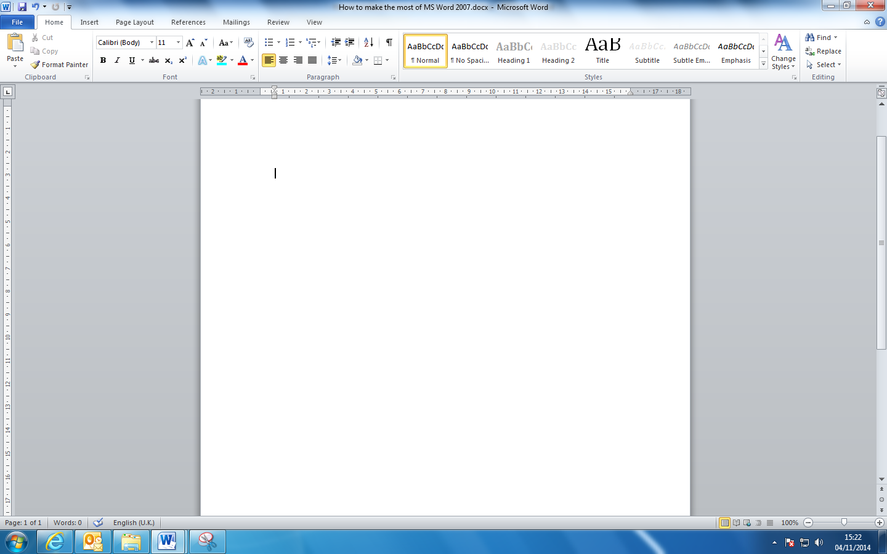

Click on ‘more’

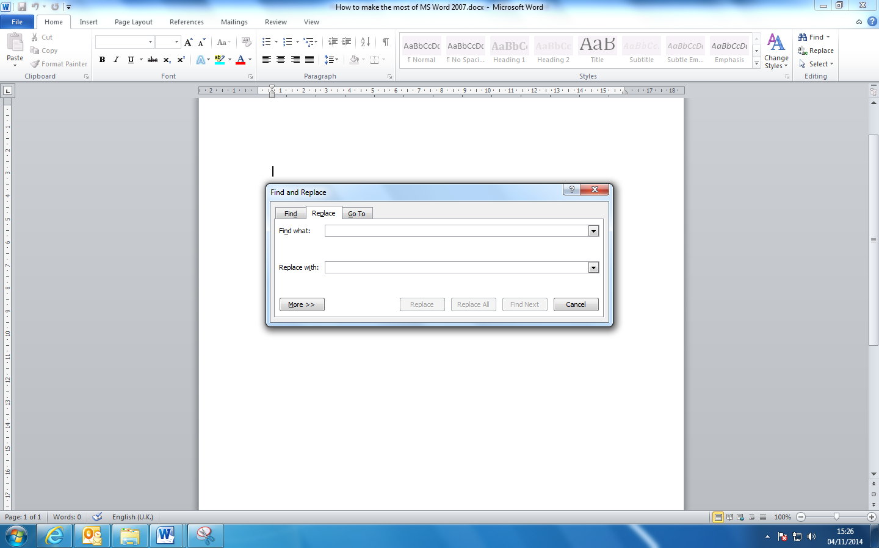and select ‘find whole words only’.

Click on ‘replace all’.