Adding speech to MS Word 2010

Select ‘More Commands’

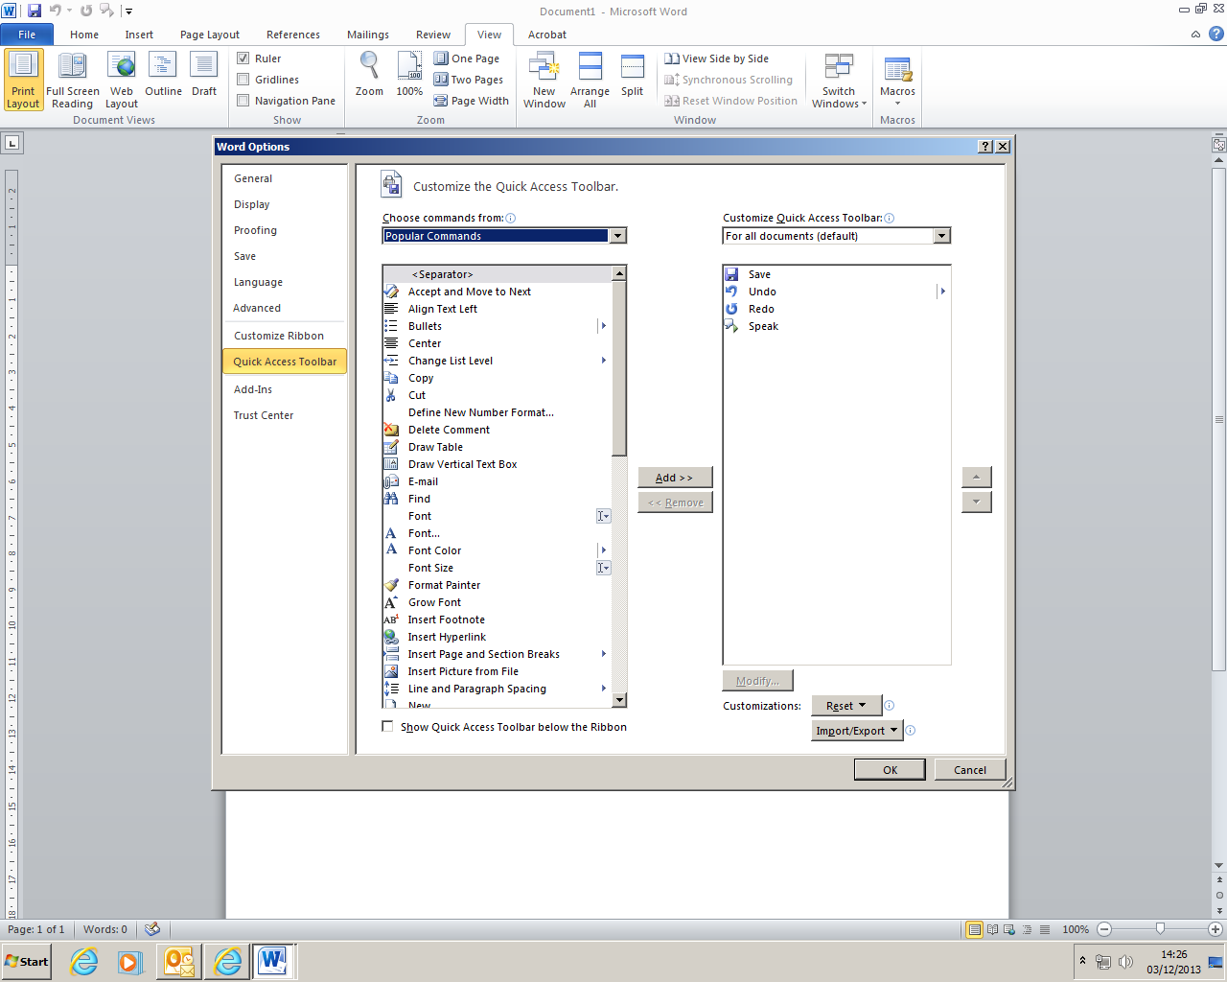

Use dropdown menu by ‘Popular Commands’ to select ‘Commands not in the ribbon’

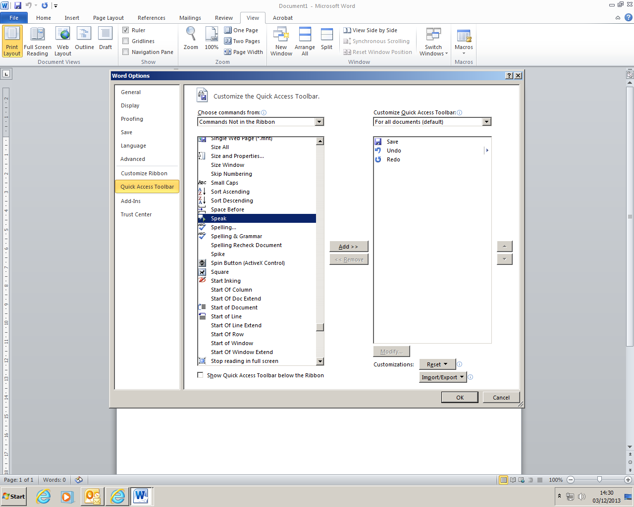

Scroll down to select ‘Speak’ → ‘Add’ → ‘OK’

Speech bubble will appear on Quick Access Toolbar

Autosummary Tools
In Word 2007, you can also use the same route to add ‘Autosummary Tools’ to the Quick Access Toolbar. This feature is not available in Word 2010

Colour
Change page colour background → Page Layout Tab → Page colour

