RNIB Bookshare – getting started

**Contents**

Step 1: Qualifying print disabilities 2

Step 2: Primary Contact and sign-up 3

New account for your organisation 3

Existing account for your organisation 3

Step 3: Set up your staff (Sponsor) accounts 4

Step 4: Set up your learner (Member) accounts 5

Step 5: Search and download 7

Book formats 7

Find books 7

Book requests 8

Find images 9

Download from a staff (Sponsor) account 9

Download from a learner (Member) account 9

Downloading – quick guide 10

Step 6: Create reading lists 12

Create reading lists and share with your learners (Members) 12

Share reading lists with staff (Sponsors) 12

Step 7: Free built in Web Reader 13

Step 8: Using other file formats 14

Reading on a computer or device 14

PDF 14

DAISY 15

Braille 15

Step 9: Accessing structured Word files 16

DAISY to Word 16

PDF to Word 16

Microsoft Office 365 17

Further information and contact us 17

# Step 1: Qualifying print disabilities

Before signing up for your account please ensure that you have learners with qualifying print-disabilities.

This definition is taken from section 31F (2) of the Copyright and Rights in Performances (Disability) Regulations 2014.

“Disabled person” means a person who has a physical or mental impairment which prevents the person from enjoying a copyright work to the same degree as a person who does not have that impairment, and “disability” is to be construed accordingly.

Any individual who falls under the above definition may be eligible to access downloaded items from UK education collection.

This definition is broader in scope than the previous legislation and includes, but is not limited to:

* Blind and partially sighted
* Learning disability
* Physical disability
* State of arrested or incomplete development of mind

**English as an Additional Language** and **low literacy levels** are not classed as print-disabilities. These learners would need to have a print-disability, as outlined above, to be able to benefit from the accessible resources on UK education collection.

Please visit our qualifying disabilities information page for further details:

* Go to “**Is this for me?”**
* Select “**Who qualifies?”**
* Select “**qualifying print-disabilities**” for further information.

The direct link to our qualifying print-disabilities page:

* <https://www.rnibbookshare.org/cms/bookshare-me/who-qualifies/qualifications>

# Step 2: Primary Contact and sign-up

## New account for your organisation

Nominate a member of staff to be the Primary Contact for your organisation's account and ask them to sign-up for your **free UK educational organisation** account:

* Go to **rnibbookshare.org**
* Go to “**Sign up today**”
* Select “**Sign up your UK organisation**”

The direct link to the UK organisation sign up page:

* <https://www.rnibbookshare.org/signUpOrganization>

Set up of your account goes quickly and smoothly if all the details have been provided accurately and you’ve applied using a valid work email address; we cannot accept personal email accounts such as Hotmail or Gmail.

We'll double-check your account details and contact you once we've approved your account and you can then start downloading resources once you have set up your learner (Member) accounts.

If you are a **non-UK organisation** please contact us for further information:

* Go to **rnibbookshare.org**
* Go to “**Sign up today**”
* Select “**Sign up your non-UK organisation**”

The direct link to the non-UK organisation sign up enquiry page:

* <https://www.rnibbookshare.org//contactUs/Membership-and-Registration>

## Existing account for your organisation

If your organisation already has an account but you need to change the Primary Contact, you can find details of how to do this in our Help Centre:

* Go to “**Help Centre**”
* Go to “**Manage my account”**
* Select “**How do we change our organisation’s Primary Contact?**”

Direct link to our Help Centre article on changing your PC:

* <https://www.rnibbookshare.org/cms/help-center/how-do-we-change-primary-contact-our-account>

# Step 3: Set up your staff (Sponsor) accounts

Your organisation’s Primary Contact can create a Sponsor account for any members of staff within your organisation who also require access to the service and are supporting learners with print-disabilities.

All staff (Primary Contacts and Sponsors) will be able to add learners (Members) and create and share reading lists.

You can do Step 3 before we’ve approved your Primary Contact organisation account.

* Log in
* Go to "**My homepage**"
* Select "**Sponsors**" or "**Manage your list of staff...**"
* Select "**Add a sponsor**"
* Complete the details and "**Save**"
* The new Sponsor will receive a welcome email with a link to set their password. Please note this is not instant and make take a few hours to come through.

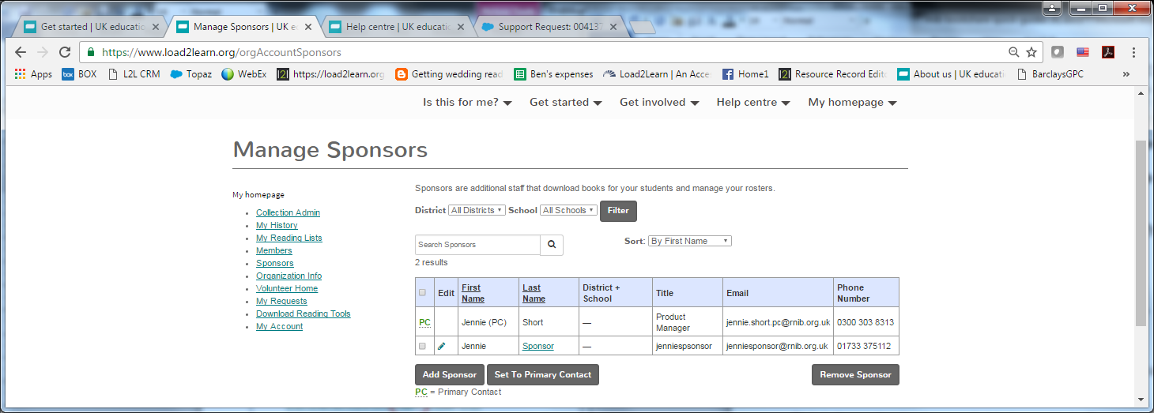

This information is also available in our Help Centre:

* <https://www.rnibbookshare.org/cms/help-center/how-do-i-add-sponsors>

# Step 4: Set up your learner (Member) accounts

You won’t be able to download resources until you’ve set up your learner (Member) accounts. You will not be able to set up these up until we've confirmed that your Primary Contact organisation account has been approved.

Giving your learners their own account gives them access to our free built-in reading tool and encourages independent study as well as allowing parents to log in using their child’s details to support home learning. It also enables us to provide accurate figures on the number of learners we're reaching so our Fundraising team can source donations to support the continued running of this free service.

* Log in
* Go to "**My homepage**"
* Go to "**Members**" or "**Manage your list of learners**"
* Select "**Add a member**"
* Complete the details and "**Save**" *
* Let your learner know their log in details

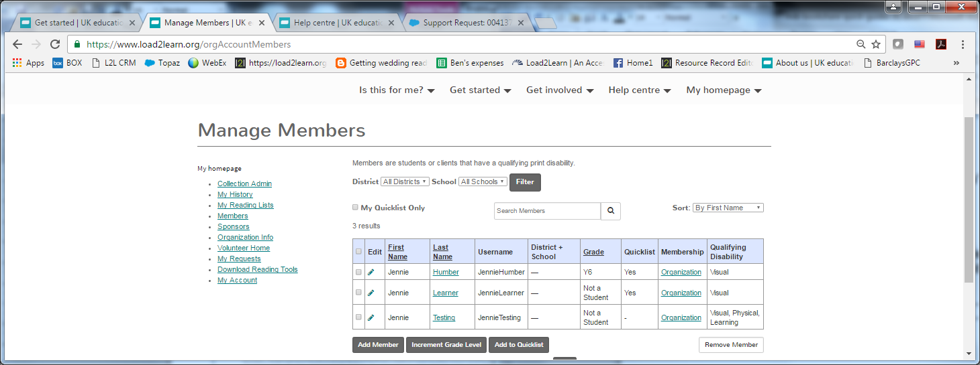

**\* To maintain learner privacy, please ensure to anonymise their details when creating their Member account. For example you could enter their true first name, with a number for their surname.**

| **Field** | **Example** |
| --- | --- |
| First name | Mary |
| Last name | Learner1 |
| Current grade | Year 5 / KS2 |
| Username | MaryLSS1 |
| Password | MaryLearner1  The password should be at least eight characters long and contain a minimum of one capital letter and one number. |
| Disability | Check relevant boxes |
| Download preferences | Setting a format preference does not stop you from seeing any of the others, it simply makes it the first option to appear when you select a book to download.  This means you don’t have to enter the drop down menu each time to select the format your learner uses the most. |
| District | IGNORE this field |
| School | IGNORE this field |

This information is also available in our Help Centre:

* <https://www.rnibbookshare.org/cms/help-center/how-do-i-add-members>

# Step 5: Search and download

## Book formats

PDF - the book record title will state “(PDF)” at the end of it and is only downloadable as a PDF.

EPUB - the book record title will not have anything at the end of it and it can be downloaded in the following formats:

* Daisy with images
* Daisy text only
* Audio (DAISY or MP3)
* Unified English Braille (Contracted or Uncontracted)
* EPUB
* EPUB through the build in Web Reader tool “Read now” – this download option is only presented when logged into a learner (Member) account.

Note: the EPUB download option is only available if it was added to the collection in either EPUB 2, EPUB 3 or RTF format.

## Find books

The quickest way to find the book you need is to **type the ISBN into the search box** at the top of any page on the site. Enter the ISBN without any spaces or hyphens.

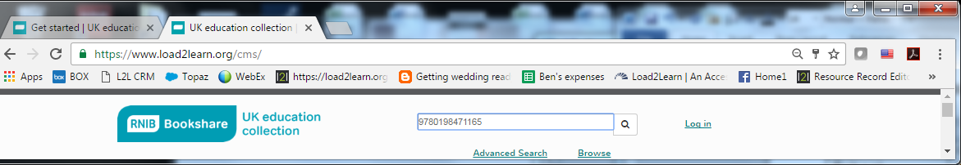

This example shows a title available that we hold both PDF and EPUB formats for and is presented in “**table view**”. You can switch between a table or list view depending on your preference. To change it select “**list view**”

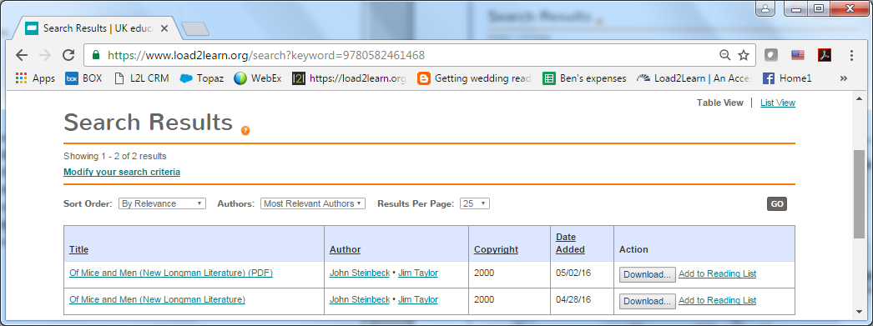

If you were logged into your **learner’s Member account**, you would also be presented with a “**Read now**” option for the file we hold as an EPUB.

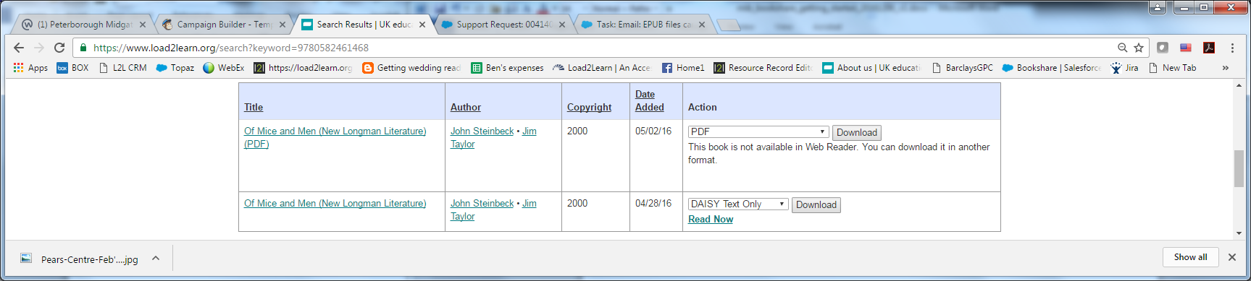

Further guidance on finding books can be found on the site:

* Go to the site’s homepage by selecting the RNIB logo in the top left
* Go to “**Books, Images, Exams, Music**”
* Select “**Books**”
* Select “**How to find books**”

The direct link to the finding books page:

* <https://www.rnibbookshare.org/cms/get-started/how-find-books>

## Book requests

If the book isn't available you’ll be directed the “**Advanced search**” form. Do not complete this search form.

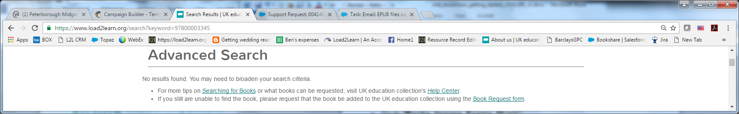

Select the link to the “**Book request form**” and let us know the title and ISBN of the book you need. We’ll then do our best to get a file from the publisher.

We work with around 200 publishers and further **guidance on how to submit your book requests** can be found on the website. Please ensure to familiarise yourself with the information on this page:

* Go to the site’s homepage by selecting the RNIB logo in the top left
* Go to “**Books, Images, Exams, Music**”
* Select “**Books**”
* Select “**Request a book**”

The direct link to our book request information:

* <https://www.rnibbookshare.org/cms/get-started/find-books/request-book>

## Find images

We've a large collection of large print and tactile images in the collection covering a range of curriculum subjects.

* Go to the site’s homepage by selecting the RNIB logo in the top left
* Go to “**Books, Images, Exams, Music**”
* Select “**Images**”
* Select “**Finding images**”

The direct link to our catalogue of images:

* <https://www.rnibbookshare.org/cms/finding-images>

If the accessible image you need isn't available you can submit an image request (using the book request form) and we'll get in touch to discuss this further with you:

* <https://www.rnibbookshare.org/bookRequest>

## Download from a staff (Sponsor) account

A full illustrated guide on how to download from a staff (Sponsor) account can be found in our Help Centre:

* Go to “**Help Centre**”
* Search for “**How do I download from a staff (Primary Contact or Sponsor) account?**”

The direct link to the Help Centre article:

* <https://www.rnibbookshare.org/cms/help-center/how-can-i-download-staff-primary-contact-or-sponsor-account>

## Download from a learner (Member) account

A full illustrated guide on how to download from a learner (Member) account can be found in our Help Centre. This includes information on the “**Read now**” option available to learners.

* Go to “**Help Centre**”
* Search for “**How do I download from a learner (Member) account?**

The direct link to the Help Centre article:

* <https://www.rnibbookshare.org/cms/help-center/downloading-learner>

## Downloading – quick guide

* Search for the book you need
* Select “Download”
* Choose the format you wish to download
* Assign the book to your learner(s), by checking the box next to their name, and download
* Confirm the download
* Selecting “Available” opens the file

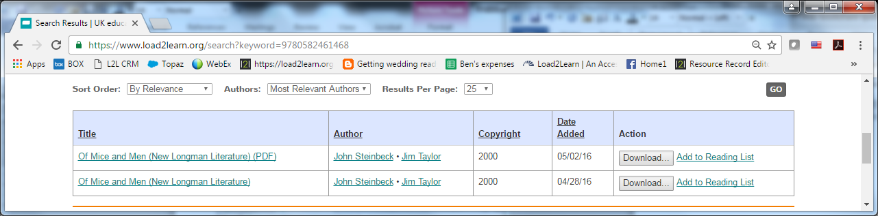

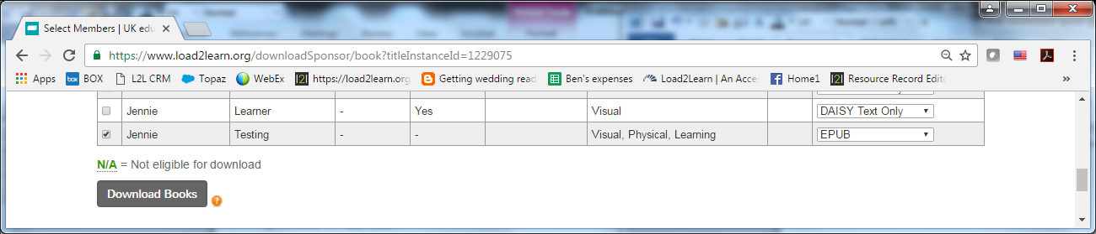

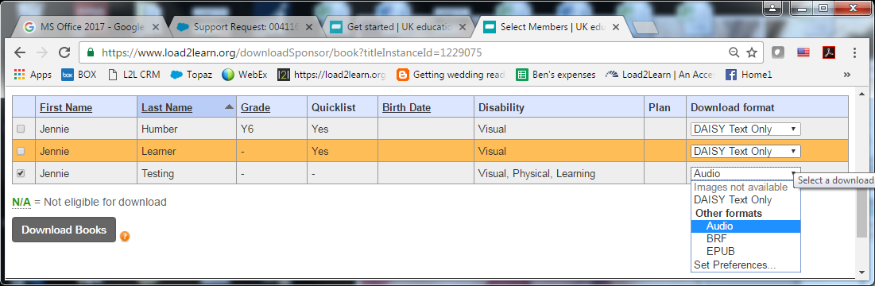

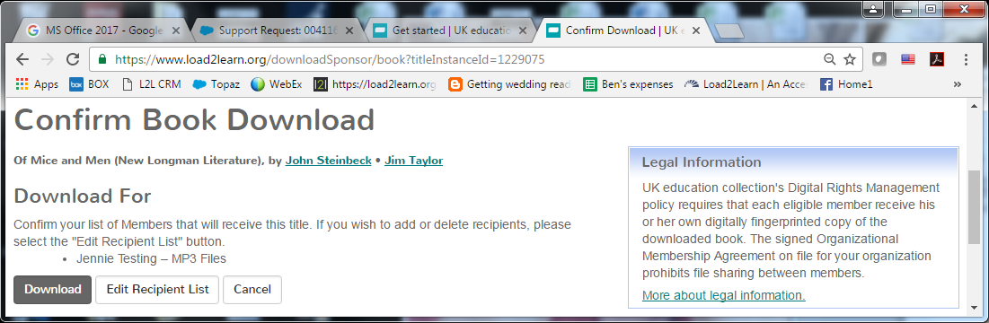

Staff (Sponsor) account – “My History”

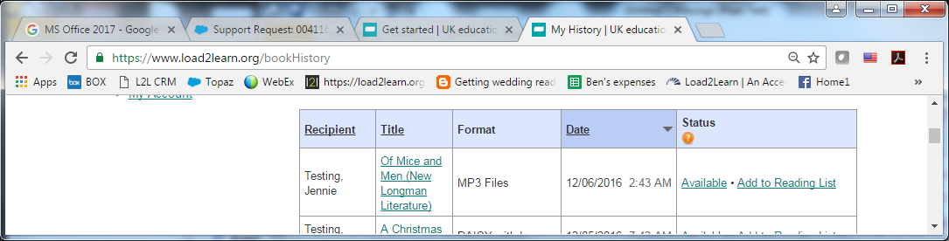

Learner (Member) account – “My History” page will display books you have downloaded and assigned to them

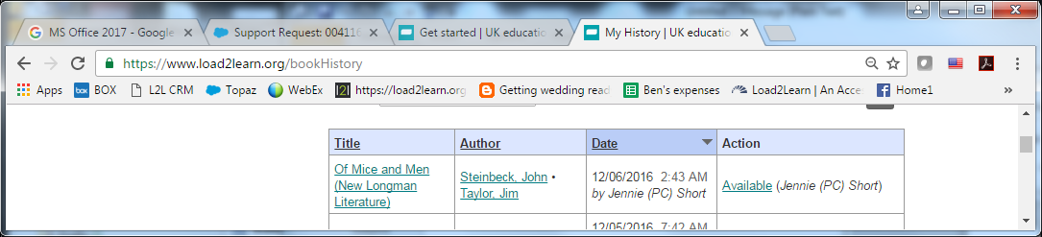

Learner (Member) account – “**My homepage**” will display the most recent titles accessed from their “**My History**” or that they have downloaded directly from their account.

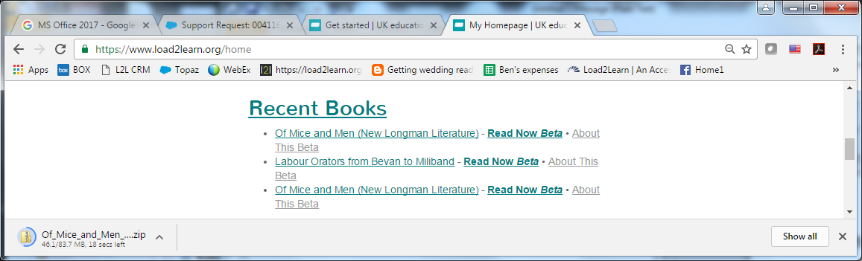

# Step 6: Create reading lists

If you find yourself needing the same books regularly, for example GCSE English Literature set texts, you can set up a reading list so you don't have to search for them each time they're needed.

You can then assign the reading list to your learners (Members) so they can quickly access the books they need to read and you can also share your reading lists with other members of staff (Sponsors).

## Create reading lists and share with your learners (Members)

Guidance on how to create reading lists and share them with your learners (Members) can be found in our Help Centre:

* Go to “**Help Centre**”
* Search for “**Reading list**”
* Select “**How do I create a reading list**?”

The direct link to the creating reading lists article:

* <https://www.rnibbookshare.org/cms/help-center/create-reading-lists>

## Share reading lists with staff (Sponsors)

Guidance on how to share your reading lists with other staff (Sponsors) can be found in our Help Centre:

* Go to “**Help Centre**”
* Search for “**Reading list**”
* Select “**How do I share a reading list**?”

The direct link to the sharing reading lists article:

* <https://www.rnibbookshare.org/cms/help-center/how-do-i-share-reading-list>

Once your reading list has been opened up for sharing, staff (Sponsors) can subscribe to it:

* Go to “**Help Centre**”
* Search for “**Reading list**”
* Select “**How do I subscribe to a shared reading list?**”

The direct link to the subscribing to reading lists article:

* <https://www.rnibbookshare.org/cms/help-center/subscribe-to-reading-lists>

# Step 7: Free built in Web Reader

Learn more about the free built in Web Reader tool available to your learners (Members) when they’re logged into their account. There is a short video in our “Get started” section, please note this video is for Bookshare (US), but will provide a good overview for how the Web Reader also works for RNIB Bookshare:

* Go to “**Get started**”
* Go to “**Read books**”
* Select “**Read on my own**”

The direct link to the video is:

* <https://www.rnibbookshare.org/cms/get-started/how-read-books/read-your-own>

Titles we host in EPUB format (not PDF) will offer learners (Members) a “**Read now**” download option:

* The learner (Member) logs into their account
* Find the title they need
* Select “**Read now**”
* The book file will open in their web browser

To read with text-to-speech and word highlighting use:

* Google Chrome on a PC or MAC
* Safari on a MAC

Note: the text-to-speech does not work on an iPad. See “Reading on a computer or device” under Step 8 for guidance on using different reading apps.

# Step 8: Using other file formats

## Reading on a computer or device

**Learn** how different file formats can be read on a computer or device; such as on a laptop, an iPad, with accessibility software and apps and other devices such as a BrailleNote or Victor Reader Stream:

* Go to “**Get started**”
* Go to “**Read books**”
* Select “**Learn about the different apps and software**”

Direct link to our “Reading on a computer or device” page:

* <https://www.rnibbookshare.org/cms/reading-computer-or-device>

## PDF

PDFs can be viewed on PCs, laptops, android tablets, iPads and Kindles (Paperwhite).

### Transferring PDF’s to iBooks

Newer iPad’s allow you to download a book from RNIB Bookshare, through Safari, and then save it directly into the iBooks app. Making it quick and easy for the learner to access books whenever they need to.

Older iPads may require you to download the book using your PC and use iTunes to sync your bookshelf content with the iBooks app on your iPad - in order for the book to remain saved in iBooks after you've closed the app.

If you don’t already have iTunes installed it can be downloaded for free from Apple UK:

* <http://www.apple.com/uk/itunes/download/>

Guidance on how to transfer the PDF to iBooks can be found in our Help Centre:

* Go to “**Help Centre**”
* Search for “**PDF**”
* Select “**How can I save PDF books to iBooks on my iPhone/iPad?**”

The direct link to the Help Centre article:

* <https://www.rnibbookshare.org/cms/help-center/how-can-i-save-PDF-ibooks>

### Save PDF books to Kindle app

The benefit of using the Kindle app on a device is that it will reflow the text of a PDF when increasing or decreasing the font size, thereby eliminating the need to scroll left to right to read each line.

A full illustrated guide on how to use the PDF with the Kindle app can be found in our Help Centre:

* Go to “**Help Centre**”
* Search for “**PDF**”
* Select “**How can I save PDF books to Kindle App?**”

The direct link to the Help Centre article:

* <https://www.rnibbookshare.org/cms/help-center/how-can-i-save-pdf-books-kindle-app>

## DAISY

The DAISY files downloading from RNIB Bookshare are DAISY 3.0. The text files work with just about every type of accessible technology that reads text and supports DAISY 3.0 (not DAISY 2.02); such as screen readers, self-voicing synthetic-voice DAISY players, braille notetakers, portable self-voicing DAISY players, and scan-and-read software such as Read:OutLoud.

Further information about DAISY can be found in our Help Centre:

* Go to “**Help Centre**”
* Search for “**DAISY**”
* Select “**DAISY information**”

The direct link to the Help Centre article on DAISY:

* <https://www.rnibbookshare.org/cms/help-center/daisy-information>

## Braille

You can visit our braille information pages to learn more about using our Braille Ready Files (BRF):

* Go to the site’s homepage by selecting the RNIB logo in the top left
* Go to “**Books, images, exams, music**”
* Select “**braille files**” (under “books”)

The direct link to the braille information page:

* <https://www.rnibbookshare.org/cms/help-center/training-and-resources/braille>

# Step 9: Accessing structured Word files

## DAISY to Word

If you need a MS Word document in order to create a modified large print edition for your learner, the structured Word file format can be easily obtained by downloading the DAISY file and running it through our DAISY to Word generator tool.

Our tool makes converting our DAISY files to a structured Word document with style mark-up quick and easy for you. The tool is in a Zip file and we can't add it to the site yet (we're working on this). If you'd like us to send it out to you please contact us.

Further information on converting DAISY files to structured Word files can be found in our Help Centre:

* Go to “**Help Centre**”
* Search for “**Word**”
* Select “**How do I can get a Word file that I can modify**?”

The direct link to the Help Centre article on creating Word documents:

* <https://www.rnibbookshare.org/cms/help-center/word-files>

## PDF to Word

Should you need to create a structured Word file from a PDF you’ll need software such as Adobe Acrobat Professional or one of the free options that are also available.

Guidance on modifying learning resources can be found on the RNIB website and includes a video comparing five different online PDF conversion programmes.

* Go to [**rnib.org.uk**](http://www.rnib.org.uk)
* Search for “**PDF to Word**”
* Select “**A quick way to modify learning resources**”

Direct link to the modifying learning resources page on the RNIB website:

* <http://www.rnib.org.uk/insight-online/quick-way-modify-learning-resources>

## Microsoft Office 365

In January 2017 MicroSoft will launch their new version of Word (as part of the Office 365 package) which will import and export EPUB for reading. They plan to incorporate editing functions in the future. Their new web browser, Edge (replacing Internet Explorer), will also have EPUB reading capabilities.

# Further information and contact us

Further information on using the files in our collection and producing accessible electronic documents can be found on our information pages and in our Help Centre.

Our online contact form: <https://www.rnibbookshare.org/contactUs>

Phone: **0300 303 8313**

Email: [bookshare@rnib.org.uk](mailto:bookshare@rnib.org.uk)

Website: [rnibbookshare.org](http://www.rnibbookshare.org)

Facebook: [facebook.com/RNIBBookshareUK](https://www.facebook.com/RNIBBookshareUK)

Twitter: [@RNIBBookshare](https://twitter.com/RNIBBookshare)

RNIB Bookshare, Reading Services, Midgate House – Floor 1, Midgate, Peterborough, PE1 1TN

---

Author: RNIB Bookshare

Date created: 6 December 2016

Last updated: 6 December 2016, Version 2

Saved: M:\RNIB Bookshare\Guidance and training for customers\Getting started\RNIB_Bookshare_getting_started_20161206_v2.docx