

Level 3

Dyslexia Awareness

**Qualification No: 601/2437/4 Unit No: H/505/9075**

# Participant’s Name:……………………………………………………..

Tutors:

Philippa Baillie, Victoria Walters, Karen Goulden, Belinda O’Brien



Contact Us

**TUTORS**

**Philippa Baillie p_baillie@taverhamhigh.org**

**Victoria Walters v_walters@taverhamhigh.org**

**Karen Goulden k_goulden@taverhamhigh.org**

**Belinda O’Brien b.obrien@taverhamhigh.org**

**ADMINISTRATOR:**

**Laura Bates dosadmin@taverhamhigh.org**

**Telephone: 01603 860505 ex 239**

**Address: The Dyslexia Outreach Service**

**Taverham High School**

**Beech Avenue**

**Taverham**

**Norwich**

**NR8 6HP**

**Website: www.dyslexiaoutreach.co.uk**

I N D E X

**Course Outline 3**

**Module Completion Checklist 5**

**Learning Outcomes and Assessment Criteria 6**

**Assessment Criteria Evidence Summary 7**

**Independent Work: Pre-course Task 9**

**Module 1: An exploration of dyslexia 10**

**Module 2: An exploration of dyslexia and working memory 20**

**Module 3: An exploration of dyslexia and processing speed 26**

**Module 4: An exploration of dyslexia and phonological skills, vocabulary and 32**

**oral communication**

**Module 5: An exploration of dyslexia and reading 39**

**Module 6: An exploration of dyslexia and writing and spelling 47**

**Module 7: An exploration of dyslexia and maths learning difficulties 57**

**Module 8: An exploration of dyslexia and assessment 64**

**Independent work: Sources of information, advice and guidance related 71**

**to dyslexia**

**Independent work: Definitions of dyslexia 73**

**Welcome to the Level 3 Dyslexia Awareness course.**

This course will develop your understanding of dyslexia and how to support learners with dyslexia.

The course comprises 8 modules related to different aspects of dyslexia:

* Module 1: Dyslexia awareness
* Module 2: Dyslexia and working memory
* Module 3: Dyslexia and processing speed
* Module 4: Dyslexia and phonological skills, vocabulary and oral communication
* Module 5: Dyslexia and reading
* Module 6: Dyslexia and writing and spelling
* Module 7: Dyslexia and maths
* Module 8: Dyslexia and assessment

The award of the Level 3 Dyslexia Awareness qualification is based on your demonstration of knowledge in all 8 modules. This will be evidenced in a portfolio.

As part of this course, you will be expected to:

1. **Meet with your tutor**

There will be the option to meet with your tutor once per term. These meetings will be used to provide you with any support you may need and answer any questions you may have, as well as to discuss progress. Whilst these meetings will be scheduled, your tutor will be available to answer questions or meet with you at any point during the course should you need it.

1. **Training**

If you have recently attended a dyslexia awareness training session in school or elsewhere, you can reference this and include notes made from your session in your portfolio.

If you have not had access to any general dyslexia awareness training, you will be signposted to online training that will provide you with a broad overview to help you get started with the course.

1. **Access pre-recorded bite-sized training (optional)**

You will be able to access pre-recorded bite-sized training, covering a range of topics relevant to the modules. These recordings are released regularly throughout the year, focusing on practical strategies to support learners with dyslexia.

1. **Undertake independent work**

This course involves a high degree of independent learning that allows you to work at your own pace and access resources and training that is best suited to your own setting. Full guidance and access to relevant resources will be given to support you with this work.

Independent Work may include **any or all** of the following.

* Watching short video clips
* Reading articles around a topic
* Using supporting resources provided in this portfolio
* Exploring useful websites to support you and inform colleagues

**Course duration:** The course is designed to be completed within one year. However, there is flexibility within the course for those who wish to complete it in a slightly shorter or longer timeframe.

**Achieving the Level 3 qualification**

The evidence you have collected will be collated into a portfolio. This can be submitted as soon as all modules have been completed.

Your portfolio will be viewed by your tutors and may also be sampled as part of the verification and quality assurance process by an Internal Quality Assurer and/or External Quality Assurer from Gateway Qualifications. Verification takes place twice a year, usually in the Spring and Summer term.

**Results and certificates:** Results will be given following verification and certificates will be issued the following month.

**Confidential Information:** Please ensure that any information related to any learners is fully anonymised to ensure that they cannot be identified in any way. This could mean referring to the learner by initials or ‘learner X’, for example

**Portfolio Completion Checklist**

Before submitting your folder, please complete the grid below to ensure you have addressed all of the course components.

|  |  |
| --- | --- |
| **Course component completed** | **Yes (please tick)** |
| **Module 1: Dyslexia Awareness**  **Pages 11, 12, 13, 14-17, 18** |  |
| **Module 2: Working memory**  **Pages 21, 22, 23, 24** |  |
| **Module 3: Processing speed**  **Pages 27, 28, 29, 30** |  |
| **Module 4: Phonological skills, vocabulary and oral communication**  **Pages 33, 34, 35, 36** |  |
| **Module 5: Reading**  **Pages 40, 41, 42, 43, 44, 45** |  |
| **Module 6: Spelling and writing**  **Pages 48, 49, 52, 54, 56** |  |
| **Module 7: Maths**  **Pages 58, 59 61, 62** |  |
| **Module 8: Assessment**  **Pages 65, 66, 67, 68, 70** |  |
| **Independent work: Sources of information, advice and guidance related to dyslexia**  **Pages 71, 72** |  |
| **Independent work: Definitions of dyslexia**  **Pages 73, 74** |  |

**Learning Outcomes and Assessment Criteria**

**What you should achieve on this course and what you need to show evidence of:**

|  |  |
| --- | --- |
| **Learning Outcomes**  The learner will: | **Assessment Criteria**  The learner has achieved this outcome because he/she can: |
| |  | | --- | | 1. Understand what is meant by ‘dyslexia’. | | |  | | --- | | * 1. Identify different definitions of ‘dyslexia’ and the key differences between them.   1.2 Explain the characteristic features of dyslexia.  1.3 Explain how individuals might experience dyslexia differently, depending on the severity and persistence of their dyslexia and the area/s (e.g. visual, auditory, motor) most affected. | |
| |  |  | | --- | --- | | |  | | --- | | 2. Understand dyslexia assessment. | | | |  | | --- | | 2.1 Explain the sorts of evidence that may indicate dyslexia.  2.2 Explain the different methods of assessment used to determine if an individual has dyslexia, outlining key differences between them. | |
| 3. Understand the impact of dyslexia on the individual. | |  | | --- | | 3.1 Analyse the possible social, emotional  and behavioural impact of dyslexia on an individual.    3.2 Explain the different ways in which dyslexia can affect an individual’s learning depending on the severity and persistence of their dyslexia and the area/s (e.g. visual, auditory, motor) most affected. | |
| |  | | --- | | 4. Know about strategies that can be used to support the learning of individuals with dyslexia. |  |  | | --- | |  | | |  |  | | --- | --- | | |  | | --- | | 4.1 Describe different strategies and interventions which can be used to support the learning of individuals with dyslexia. | | |
| 5. Know about sources of information, advice and guidance relating to dyslexia. | 5.1 Summarise the different sources and types of  support available to individuals with dyslexia, their  families and those supporting their learning. |

**Assessment Criteria Evidence Summary**

I have evidence in my portfolio that demonstrates I understand the effects of dyslexia and can support a dyslexic individual in the areas listed below.

Name:_______________________________

Signed:_______________________________ Date:_______________________________

|  |  |  |
| --- | --- | --- |
| **Assessment Criteria** | **Workbook Page** | **Assessment criteria achieved** |
| |  | | --- | | 1.1 Identify different definitions of ‘dyslexia’ and the key differences between them. | | 9, 73, 74 |  |
| 1.2 Explain the characteristic features of dyslexia. | 13, 42, 43, 52 |  |
| 1.3 Explain how individuals might experience dyslexia differently, depending on the severity and persistence of their dyslexia and the area/s (e.g. visual, auditory, motor) most affected. | 18, 61 |  |
| |  | | --- | | 2.1 Explain the sorts of evidence that may indicate dyslexia. | | 42, 43, 52, 61, 67, 68 |  |
| 2.2 Explain the different methods of assessment used to determine if an individual has dyslexia, outlining key differences between them. | 67, 68 |  |
| 3.1 Analyse the possible social, emotional  and behavioural impact of dyslexia on an individual. | 14, 18, 23, 29, 35, 44 |  |
| |  | | --- | | 3.2 Explain the different ways in which dyslexia can affect an individual’s learning depending on the severity and persistence of their dyslexia and the area/s (e.g. visual, auditory, motor) most affected. | | 14, 23, 29, 35, 42, 43, 52, 61 |  |
| |  |  | | --- | --- | | |  | | --- | | 4.1 Describe different strategies and interventions which can be used to support the learning of individuals with dyslexia. | | | 23, 35, 44, 54, 61 |  |
| 5.1 Summarise the different sources and types of  support available to individuals with dyslexia, their  families and those supporting their learning. | 72 |  |

**Assessor comments:**

|  |
| --- |
|  |

I confirm that __________________________________________ has met the assessment criteria to the required standard.

Assessor moderation □ Date: _______________ Signed: ________________________

Signed: _____________________________ (Assessor) Date: ___________

Signed: _____________________________ (Internal Quality Assurer) Date: __________

**Pre-course Task**

**Assessment criteria: 1.1**

**Definition of Dyslexia**

|  |
| --- |
| “Dyslexia is a learning difficulty that primarily affects the skills involved in accurate and fluent word reading and spelling. Characteristic features of dyslexia are difficulties in phonological awareness, verbal memory and verbal processing speed.” (Rose, 2009). |

**As you start the Level 3 Dyslexia Awareness course, please note your thoughts below on your current understanding of dyslexia.**

**Date:**

|  |
| --- |
|  |

**Module 1**

**AN EXPLORATION OF DYSLEXIA**

**Module 1: Dyslexia Awareness**

**Please fill in the table below for this module and ensure that you have completed the activities on pages 13, 14-17 and 18.**

|  |  |  |  |
| --- | --- | --- | --- |
| **Sources of information**  Tick only the sources you have accessed. Please note this does not have to include all of the options below. | | | |
| **Type** | **Details / Content** | **Yes ✓** | **Date accessed** |
| **Dyslexia Awareness training** |  |  |  |
| **Watched video** | **My dyslexic mind: CBBC newsround special** **(14:58)**  <http://www.bbc.co.uk/newsround/20783005>  Explores what dyslexia is and some of the ways it affects children. The show's presented by 12-year-old Ben, who really struggled at school until he found out he had dyslexia. |  |  |
| **Watched video** | **BDA – See Dyslexia Differently (3:10)**  <https://www.bdadyslexia.org.uk/dyslexia/about-dyslexia/what-is-dyslexia>  This animation seeks to preempt misconceptions among young audiences by shedding light on the real challenges dyslexic children face whilst also acknowledging their strengths and potential. |  |  |
| **Read text** | **Dyslexia Explained - free ebook**  <https://www.nessy.com/uk/e-book/> |  |  |
| **Accessed website** | **What is dyslexia? Newsround guide**  <https://www.bbc.co.uk/newsround/20783002> |  |  |
| **Other** |  |  |  |

**Features of Dyslexia Assessment criteria: 1.2**

**What characteristic features of dyslexia can you identify from any of the following**

* **Training you have had**
* **Nessy Explained free ebook** [**https://www.nessy.com/uk/e-book/**](https://www.nessy.com/uk/e-book/)
* **The Nessy video** [**https://www.youtube.com/watch?v=IEpBujdee8M**](https://www.youtube.com/watch?v=IEpBujdee8M) **(7:15)**

|  |  |  |
| --- | --- | --- |
| **Bright ideas to remember - notes from any of the above sources** | | |
|  |  |  |
|  |  |  |
|  |  |  |

**Task Assessment criteria: 3.1, 3.2**

Using the dyslexia identification checklists provided:

**p15 Early Years**

**p16 Primary**

**p17 Secondary**

Select a checklist **relevant to your setting** and highlight / tick off some of the typical signs of dyslexia that you see in your learner(s).

**Pages 15, 16 & 17 to be inserted here (idp sheets)**

**Assessment criteria: 1.3, 3.1**

**The Value of Dyslexia**

|  |  |  |
| --- | --- | --- |
| **Lewis Hamilton** | **Michael Faraday** | **Liz Pichon** |
| **Orlando Bloom** | **Jo Malone** | **Steven Spielberg** |

With dyslexia, comes many talents and strengths. Several of the famous people above have attributed their success in their chosen field to their dyslexia. What potential strengths of dyslexia can you identify?

**Optional activity**

You might also like to investigate these further links and resources on famous dyslexics:

**Orlando Bloom:** article with link to videos <https://childmind.org/article/orlando-bloom-on-dyslexia>

**Kara Tointon:** ‘Don’t call me Stupid’ available in 4 parts on YouTube – approx 15 mins each part

**Mollie King:** Dyslexia made reading aloud ‘scary and intimidating’ Newsbeat article - <https://www.bbc.co.uk/news/newsbeat-48053226>

**Theo Paphitis:** Dragons' Den star says he owes his success to dyslexia <https://www.bbc.co.uk/news/business-45861658> (article and video 1.13 min)

**Henry Winkler:** article and videos on his dyslexia (4.49 min) and the Hank Zipzer books he has written (3.29 min) with a main character who is dyslexic <https://www.dyslexia-reading-well.com/henry-winkler-dyslexia.html>

|  |
| --- |
| **Supporting self esteem** |
| * Emphasise the positive – what the learner can do. * Look for, recognise and value learners’ strengths and help them to recognise and value them too. * Use frequent, specific, task linked praise. This may need to be discreet. * Praise for small achievements. * Recognise ideas, content and effort. * Devise ‘staged’ approaches to a task to accumulate positive outcomes. * Use SMART targets. If spelling is consistently 3/10 correct, reduce spellings to 3 to achieve 100%. * Develop strategies to encourage independence. * Be aware of effort required for tasks. * Avoid exposing weakness in front of peers |

**Module 2**

**AN EXPLORATION OF DYSLEXIA AND WORKING MEMORY**

**Module 2: Dyslexia and Working Memory**

**Please fill in the table below for this module and ensure that you have completed the activities on pages 23 and 24.**

|  |  |  |  |
| --- | --- | --- | --- |
| **Sources of information**  Tick only the sources you have accessed. Please note this does not have to include all of the options below. | | | |
| **Type** | **Details / Content** | **Yes ✓** | **Date accessed** |
| **Attended training session** |  |  |  |
| **Accessed pre-recorded bite-sized training** |  |  |  |
| **Watched video** | **A brief exploration of the Baddeley and Hitch 1974 model of Working Memory (4:26)**  <https://www.youtube.com/watch?v=1xwNFb9tsxg>  An explanation of the key components of working memory - the Central Executive, The Phonological Loop, the Visuo-Spatial Sketchpad and the Episodic Buffer. |  |  |
| **Watched video** | **Memory techniques with Antony Reale (3:50)**  <https://www.youtube.com/watch?v=WZjj5CvAaC0&t=103s&list=PL9lM9yWgzpSzJOTEQpY16xuYePohgpkmV&index=8>  Dyslexic learners can have difficulty with memory. This video shows ways you can help your learner develop techniques to remember sequences or a string of instructions. The techniques considered include chunking, visualising, verbal & visual mnemonics, creating associations. This ability will help in all areas of life. |  |  |
| **Read text** | **Understanding Working Memory – A classroom guide (Gathercole & Alloway 2007)**  <https://pdnet.org.uk/media/WM-classroom-guide.pdf>  An introduction to working memory and the role it plays in everyday life with particular reference to school. The learning difficulties commonly faced by children with reduced working memory capacity are described and a programme of classroom support is outlined. |  |  |
| **Accessed website** | **Brainsmart** <http://www.bbc.co.uk/scotland/brainsmart/>  Fun website with articles, videos & games around memory and techniques to help you maximise memory capacity |  |  |
| **Accessed website** | **Quick Guide to Dyslexia & Working Memory Issues**  <http://www.defeat-dyslexia.com/2016/04/a-quick-guide-to-dyslexia-and-working-memory/>  Also links to further information on helpful memory techniques/strategies |  |  |
| **Other** |  |  |  |

**Assessment criteria: 3.1, 3.2**

**From the sources of information you have accessed, please comment on:**

|  |  |
| --- | --- |
| Effects of reduced working memory capacity on … | |
| Social integration, emotional wellbeing and behaviour | Learning |
|  |  |

**Assessment criteria: 4.1**

|  |
| --- |
| [http://t1.gstatic.com/images?q=tbn:ANd9GcRuX_ZmHB3y9LuYblnq2_I_gYSUFqqaCTJPIFItz05OP7cxYhJy:1.bp.blogspot.com/-q6DxgDzr3ig/TgBCoLMwLRI/AAAAAAAAC7Y/gqridoD9Akg/s1600/lightbulb.jpeg](http://www.google.co.uk/imgres?imgurl=http://1.bp.blogspot.com/-q6DxgDzr3ig/TgBCoLMwLRI/AAAAAAAAC7Y/gqridoD9Akg/s1600/lightbulb.jpeg&imgrefurl=http://freedomlightbulb.blogspot.com/2011_11_01_archive.html&h=944&w=874&tbnid=xcJBMvvq-beHrM:&zoom=1&q=lightbulb&docid=MktSYz4Qk1nMYM&ei=DXkqVNbFCYnBOY78gPAM&tbm=isch&ved=0CHMQMyhIMEg&iact=rc&uact=3&dur=284&page=3&start=69&ndsp=36)  Strategies to support reduced working memory capacity |
|  |

|  |
| --- |
| **Module 2: Reflection on Dyslexia and Working Memory** |

When you have completed the requirements for this module, please reflect on the learning you have undertaken.

|  |
| --- |
| What did I learn that was new to me?  Assessment criteria covered: |
| How do I think it will be useful to me in my practice?  Assessment criteria covered: |

**Short term memory strategies**

* Be clear, concise & unambiguous
* Deliver instructions in 1 or 2 chunks
* Repeat sequences often
* Allow for processing time
* Ask for instructions to be repeated back to you
* Minimise stress that can result from forgetting (give praise for asking)
* Provide memory aids – mnemonics, calculator etc.
* Support with visual reference e.g. page number on board, highlight key parts in the text
* Show how to chunk in meaningful units to reduce load on working memory

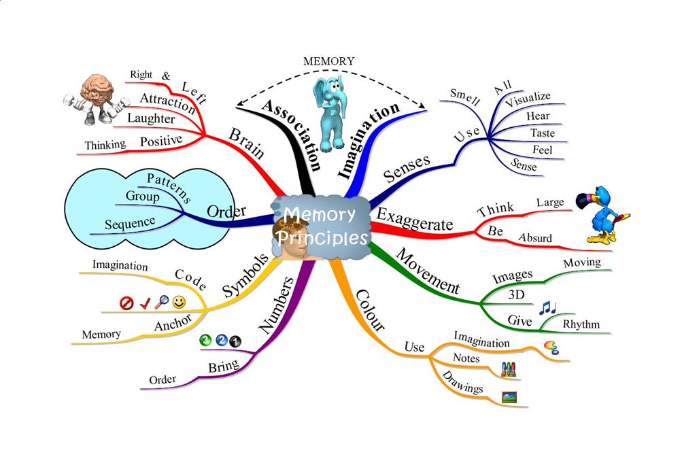

**Module 3**

**AN EXPLORATION OF DYSLEXIA AND PROCESSING SPEED**

**Module 3: Dyslexia and Processing Speed**

**Please fill in the table below for this module and ensure that you have completed the activities on pages 29 and 30.**

|  |  |  |  |
| --- | --- | --- | --- |
| **Sources of information**  Tick only the sources you have accessed. Please note this does not have to include all of the options below. | | | |
| **Type** | **Details / Content** | **Yes ✓** | **Date accessed** |
| **Attended training session** |  |  |  |
| **Accessed pre-recorded bite-sized training** |  |  |  |
| **Watched video** | What Is Slow Processing Speed? (2:30)<https://www.youtube.com/watch?v=HFa33hpMU_I> Ellen Braaten, PhD, explains what slow processing speed is and how it affects children. |  |  |
| **Watched video** | Bright Kids Who Can't Keep Up - Ellen B. Braaten, PhDDetailed look into slow processing speed over 4 part video series (not purely related to dyslexic difficulties)Part 1 <https://www.youtube.com/watch?v=3U_I2aCjMZo> (17:30) Looks at what slow processing is, how it impacts on a learner and typical assessment tasks to identify slow processing speed  **Part 2** <https://www.youtube.com/watch?v=sxSOec5fd30> **(19:02)**  Looks further at assessment tasks, history of psychological & research into brain differences,  **Part 3** <https://www.youtube.com/watch?v=I9Eq5n3hfjY> **(19:42)**  Way learners with slow processing speed may present in the classroom, what can you do - accept, accommodate & advocate, how teachers/schools can support  **Part 4** <https://www.youtube.com/watch?v=vTwD66bqiFI&t=72s> **(up to 7:11)**  Specific helpful strategies |  |  |
| **Read text** | [Bright Kids Who Can't Keep Up: Help Your Child Overcome Slow Processing Speed and Succeed in a Fast-Paced World](https://www.amazon.co.uk/Bright-Kids-Who-Cant-Keep/dp/1609184726/ref=sr_1_1?keywords=bright+kids+who+cant+keep+up&qid=1578305843&sr=8-1) by [Ellen Braaten](https://www.amazon.co.uk/Ellen-Braaten/e/B001JP494I?ref=sr_ntt_srch_lnk_1&qid=1578305843&sr=8-1)and [Brian Willoughby](https://www.amazon.co.uk/Brian-Willoughby/e/B00P205DPK?ref=sr_ntt_srch_lnk_1&qid=1578305843&sr=8-1) (available to borrow from DOS) With stories and examples, this resource demystifies processing speed and shows how to help learners catch up in this key area of development (written for USA schooling system but some good basic info and ideas). |  |  |
| **Accessed website** | **Slow Processing Speed** <https://www.readandspell.com/what-is-processing-speed>  Overview of what slow processing speed means, impact on learners & strategies to overcome |  |  |
| **Accessed website** | **Understood: Classroom Accommodations for Slow Processing Speed**  <https://www.understood.org/en/school-learning/partnering-with-childs-school/instructional-strategies/classroom-accommodations-for-slow-processing-speed> |  |  |
| **Other** |  |  |  |

**Assessment criteria: 3.1, 3.2**

|  |  |  |
| --- | --- | --- |
|  |  |  |
|  | Related image |  |
|  |  |  |

**In what ways can slow processing speed affect an individual’s learning?**

|  |
| --- |
| **Module 3: Reflection on Dyslexia and Processing Speed** |

When you have completed the requirements for this module, please reflect on the learning you have undertaken.

|  |
| --- |
| What did I learn that was new to me?  Assessment criteria covered: |
| How do I think it will be useful to me in my practice?  Assessment criteria covered: |



**Supporting slow verbal processing speed**

* Allow students ‘think time’ to process what you say – you will get better responses (10 seconds).
* Allow response time so learners can formulate their answer; e.g. at the beginning of a learning point let pupils know what questions you want them to answer at the end. Some learners need a long time to formulate spoken answers.
* Allow ‘rehearsal’ time. Encourage learners to discuss and practise their response with a partner or in a small group before they deliver in front of the whole class.
* Don’t talk when students are writing. A learner with a weak working memory needs to have as much free ‘headspace’ as possible to perform.
* Slow down your rate of speaking if possible
* Never put a pupil on the spot in front of the rest of the class - this is a sure fire way to demolish their self-esteem!

**Module 4**

**AN EXPLORATION OF DYSLEXIA AND PHONOLOGICAL SKILLS, VOCABULARY AND ORAL COMMUNICATION**

**Module 4: Dyslexia and Phonological Skills, Vocabulary and Oral Communication**

**Please fill in the table below for this module and ensure that you have completed the activities on pages 35 and 36.**

|  |  |  |  |
| --- | --- | --- | --- |
| **Sources of information**  Tick only the sources you have accessed. Please note this does not have to include all of the options below. | | | |
| **Type** | **Details / Content** | **Yes ✓** | **Date accessed** |
| **Attended training session** |  |  |  |
| **Accessed pre-recorded**  **bite-sized training** |  |  |  |
| **Watched video** | **Understood: Phonological Awareness: What You Need To Know (1:49)**  <https://www.understood.org/en/learning-thinking-differences/child-learning-disabilities/reading-issues/phonological-awareness-what-it-is-and-how-it-works>  An explanation of phonological and phonemic awareness, including a short video clip. |  |  |
| **Read text** | **Why Closing the Word Gap Matters – Oxford Language Report**  <http://fdslive.oup.com/www.oup.com/oxed/Oxford-Language-Report.PDF?region=uk>  Selection of articles from academics and practitioners on the ‘word gap’ issue for primary and secondary pupils and practical ideas for how schools can address this |  |  |
| **Read text** | **Closing the Vocabulary Gap** by Alex Quigley 2018 (available to borrow from DOS)  **An overview of the research on learning vocabulary, and practical advice on how to apply this research in the classroom.** |  |  |
| **Accessed website** | **Reading Rockets**  <https://www.readingrockets.org/article/development-phonological-skills>  An explanation of the progression of phonological skills and the ages at which the skills are expected to be acquired. |  |  |
| **Accessed website** | **Improving phonological awareness skills for older children**  <https://www.speechandlanguagekids.com/improving-phonological-awareness-skills-older-children-already-reading/>  Speech & language therapists website with 6 min video with ideas and activities for improving phonological awareness skills for older children who are already reading. |  |  |
| **Other** |  |  |  |

**Assessment criteria: 3.1, 3.2**

**From the sources of information you have accessed, please comment on:**

|  |  |
| --- | --- |
| Effect of poor phonological skills, vocabulary development & oral communication difficulties on... | |
| Social integration, emotional wellbeing and behaviour | Learning |
|  |  |

**Assessment criteria: 4.1**

|  |
| --- |
| [http://t1.gstatic.com/images?q=tbn:ANd9GcRuX_ZmHB3y9LuYblnq2_I_gYSUFqqaCTJPIFItz05OP7cxYhJy:1.bp.blogspot.com/-q6DxgDzr3ig/TgBCoLMwLRI/AAAAAAAAC7Y/gqridoD9Akg/s1600/lightbulb.jpeg](http://www.google.co.uk/imgres?imgurl=http://1.bp.blogspot.com/-q6DxgDzr3ig/TgBCoLMwLRI/AAAAAAAAC7Y/gqridoD9Akg/s1600/lightbulb.jpeg&imgrefurl=http://freedomlightbulb.blogspot.com/2011_11_01_archive.html&h=944&w=874&tbnid=xcJBMvvq-beHrM:&zoom=1&q=lightbulb&docid=MktSYz4Qk1nMYM&ei=DXkqVNbFCYnBOY78gPAM&tbm=isch&ved=0CHMQMyhIMEg&iact=rc&uact=3&dur=284&page=3&start=69&ndsp=36)Strategies for developing oral communication skills. You might find it helpful to think about early phonological development, vocabulary development and wider oral communication |
|  |

|  |
| --- |
| **Module 4: Reflection on Dyslexia and Phonological Skills, Vocabulary & Oral Communication** |

When you have completed the requirements for this module, please reflect on the learning you have undertaken.

|  |
| --- |
| What did I learn that was new to me?  Assessment criteria covered: |
| How do I think it will be useful to me in my practice?  Assessment criteria covered: |

**Glossary**

**Phonological awareness**: the explicit awareness of the sound segments in words; the capacity to reflect upon and manipulate the sound structure of words.

**Phonological processing:** the ability to process sounds in spoken language.

**Phonics:** the teaching of reading and spelling by sounding out individual letter sounds, blending sounds to read, segmenting sounds to spell.

**Phoneme:** the smallest unit of sound

**Grapheme:** the written representation of a phoneme; that is a letter or group of letters representing a sound.

**Vowel:** the letters a, e, i, o and u

**Consonant:** all other letters in the English language

**Digraph:** two letters which combine to represent one sound (i.e. *ch*ip, sti*ck*)

**Vowel digraph:** two vowels which combine to represent on vowel sound (i.e. *ou*t, b*oa*t, *au*dit)

**Split (vowel) digraph:** two vowels combine to make one sound but are separated by a consonant (i.e. b*i*t*e,* t*u*b*e*, h*o*p*e*)

**Trigraph:** three letters representing one sound (i.e. he*dge*, h*air,* sna*tch*)

**Consonant cluster:** two or three letters making two or three individual consonant sounds (i.e. *st*rict, *bl*ow)

**Segmenting sounds:** splitting words into their phonemes

**Sight word:**  a) a very common word that needs to be recognised instantly, i.e. is, at, in or

b) a word that cannot easily be sounded out and therefore needs to be recognised, i.e. through, said, your

**Synthesising sounds:** combining phonemes to make words

**Syllable:** a unit of pronunciation having one vowel sound, with or without surrounding consonants, forming the whole or a part of a word (i.e. in-fer-no)

**Closed syllable:** a syllable ending in a consonant (i.e. mis/fit) **Open syllable:**  a syllable ending in a vowel (i.e. re/peat)

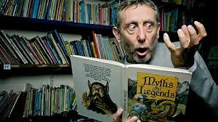**Developing oral skills: some strategies**

1. Read to children frequently – even older ones – from a variety of texts. Do not neglect poetry as rhyme is an important skill in developing oral language.

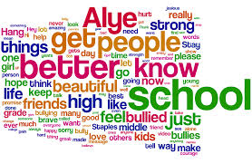

1. Teach vocabulary explicitly. Talk about

what a word looks like/ rhymes with/ the

number of syllables within the word/ what it

means and how it would be used in a sentence.

1. Provide speaking frames to develop confidence in oral language.

* I know that because….
* I agree with (name) because….
* In some ways………and……..are alike. For instance they both………………………..
* Another feature they have in common is that………………………
* Furthermore they are both………………………
* However they also differ in that…. For example……………..whereas…………….
* The similarities/differences seem more significant than the similarities/differences because…



1. Make time and plan for children to talk to each other formally and informally. Set up role plays areas even for older children. Link the area to topics being covered in class (French café, World War I trenches, science labs etc).
2. <https://speechandlanguage.org.uk/talking-point/for-professionals/the-communication-trust/> is a helpful website for ideas and resources. It also provides milestones of how a child’s oral skills develop from birth to 11.

<https://wordsforlife.org.uk/> is a good site for finding ryhmes and songs.

**Module 5**

**AN EXPLORATION OF DYSLEXIA AND READING**

**Module 5: Dyslexia and Reading**

**Please fill in the table below for this module and ensure that you have completed the activities on pages 42, 43, 44 and 45.**

|  |  |  |  |
| --- | --- | --- | --- |
| **Sources of information**  Tick only the sources you have accessed. Please note this does not have to include all of the options below. | | | |
| **Type** | **Details / Content** | **Yes ✓** | **Date accessed** |
| **Attended training session** |  |  |  |
| **Accessed**  **pre-recorded**  **bite-sized training** |  |  |  |
| **Watched video** | **What is reading? The Simple View (1:55)**  <https://www.youtube.com/watch?v=cUoiZl-ep7E>  An explanation of the simple view of reading. |  |  |
| **Read text** | **Downloadable document on making text more accessible to dyslexic learners:** <https://www.bdadyslexia.org.uk/advice/employers/creating-a-dyslexia-friendly-workplace/dyslexia-friendly-style-guide> |  |  |
| **Accessed website** | **Beating Dyslexia – Reading Strategies**  <https://www.beatingdyslexia.com/reading-strategies.html>  Information on typical reading difficulties experienced by dyslexic learners and strategies to support. Information given can be accessed through text or video. |  |  |
| **Accessed website** | **Reading Rockets**  <https://www.readingrockets.org/reading-topics/dyslexia>  Large US website with many articles & videos on reading decoding, fluency and comprehension – issues & strategies to help. |  |  |
| **Other** |  |  |  |

**Assessment criteria: 1.2, 2.1, 3.2**

**The simple view of reading**

**https://improvingliteracy.org/brief/learning-read-simple-view-reading**

|  |
| --- |
| **Indicate on the grid where a learner with dyslexia might fit:** |
| Good language comprehension processes  Poor word recognition processes  Good word recognition processes  Poor language comprehension processes |

**Assessment Criteria: 1.2, 2.1, 3.2**

**Profile of Struggling Readers**

Thinking about the reading skills profile of a dyslexic learner that you know, indicate whether their reading behaviours impact on word reading, comprehension or both.

|  |  |  |  |
| --- | --- | --- | --- |
| **Reading skills profile** | **Word recognition** | **Comprehension** | **Both** |
| **Makes errors on small words e.g. *of, and, are*** |  |  |  |
| **Concentrates on decoding words (e.g. sounding out) and may not pay attention to the meaning** |  |  |  |
| **Decoding attempts results in nonsense words** |  |  |  |
| **Uses only initial phoneme to tackle unfamiliar words** |  |  |  |
| **Very slow reading pace – robotic reading style** |  |  |  |
| **Ignores punctuation** |  |  |  |
| **Unconcerned whether words make sense and little or no attempt at self-correction** |  |  |  |
| **No reading stamina** |  |  |  |
| **Confuses visually similar words** |  |  |  |
| **Can successfully read the word but can’t say what it means** |  |  |  |

**Assessment criteria: 3.1**

**From the sources of information you have accessed, please comment on:**

|  |  |
| --- | --- |
| Effects of poor word recognition on… | |
| how others see the learner | the learners’ view of themselves |
|  |  |

[](http://www.google.co.uk/imgres?imgurl=http://1.bp.blogspot.com/-q6DxgDzr3ig/TgBCoLMwLRI/AAAAAAAAC7Y/gqridoD9Akg/s1600/lightbulb.jpeg&imgrefurl=http://freedomlightbulb.blogspot.com/2011_11_01_archive.html&h=944&w=874&tbnid=xcJBMvvq-beHrM:&zoom=1&q=lightbulb&docid=MktSYz4Qk1nMYM&ei=DXkqVNbFCYnBOY78gPAM&tbm=isch&ved=0CHMQMyhIMEg&iact=rc&uact=3&dur=284&page=3&start=69&ndsp=36) **Assessment criteria: 4.1**

|  |
| --- |
| Strategies for developing word recognition and/or language comprehension |
|  |

|  |
| --- |
| **Module 5: Reflection on Dyslexia and Reading** |

When you have completed the requirements for this module, please reflect on the learning you have undertaken.

|  |
| --- |
| What did I learn that was new to me?  Assessment criteria covered: |
| How do I think it will be useful to me in my practice?  Assessment criteria covered: |

**Strategies to support reading**

1. 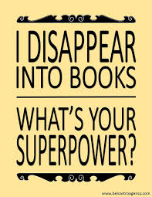Read children’s books frequently yourself and share your enjoyment of them.
2. Read aloud to your learners.
3. Promote appropriate books continuously.
4. Make sure pupils read aloud to someone daily but don’t ask a dyslexic pupil to read aloud in front of a class unless you know they are happy to do so.
5. Have a small selection of books available that work for learners with dyslexia (books with a dyslexia-friendly font for example).
6. 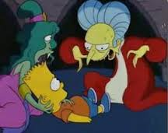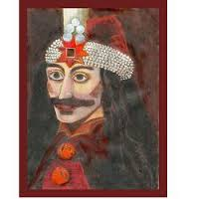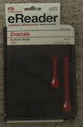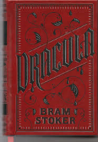Get the same book in as many different formats as you can think of: paper, audio, electronic, graphic, abridged, film, TV, spoof.



1. Identify books which are of interest to reluctant readers (e.g. Books with Hooks from

the National Literacy Trust).

1. Introduce paired / shared reading activities to improve reading fluency, aid understanding and build confidence.
2. Allow learners time to tune into books before they have to read. Revisit key characters or events from the last time you read the book together. Prepare the reader for any difficult words they may come across in the coming chapter or paragraphs.
3. Allow learners to listen to the book where possible so that they can access the same books their peers may be reading.

**Module 6**

**AN EXPLORATION OF DYSLEXIA AND WRITING AND SPELLING**

**Module 6: Dyslexia and Writing and Spelling**

**Please fill in the table below for this module and ensure that you have completed the activities on pages 52, 54 and 56.**

|  |  |  |  |
| --- | --- | --- | --- |
| **Sources of information**  Tick only the sources you have accessed. Please note this does not have to include all of the options below. | | | |
| **Type** | **Details / Content** | **Yes ✓** | **Date accessed** |
| **Attended training session** |  |  |  |
| **Accessed**  **pre-recorded**  **bite-sized training** |  |  |  |
| **Watched video** | Oxford Owl <https://www.oxfordowl.co.uk/for-home/oxford-owl-videos/spelling-vocabulary-videos/> (various lengths)  A range of short videos clips on how to support writing and spelling looking at, amongst other things, mnemonics, homophones and prefixes and suffixes. |  |  |
| **Watched video** | Engaging reluctant writers (11.48) <https://www.youtube.com/watch?v=0PfrrHBKEVg>  Presentation of variety of reasons why a learner might be reluctant to write and strategies to overcome these |  |  |
| **Read text** | Spelling Rules, Riddles and Remedies by Sally Raymond (available to borrow from DOS) Targeting learners in Key Stage 2 upwards this book encourages creativity and shows teachers how to adopt and adapt a variety of learning strategies to suit different needs. |  |  |
| **Accessed website** | **British Dyselxia Association**  <https://www.bdadyslexia.org.uk/advice/children/how-can-i-support-my-child/spelling>  Strategies and ideas on how to support children with their spelling. |  |  |
| **Accessed website** | **Call Scotland**  <https://www.callscotland.org.uk/information/dyslexia/writing/>  This website explores how technology can be used to support learners with writing and/ or spelling difficulties. |  |  |
| **Other** |  |  |  |

**Writing sample with spelling errors for Task p51-52**

“Annie I am really really sorry but I am working as much as I can but we still do not have a enough money so you I going to have to search for a job”

Annie mum sed in a very sad vois. I shall naw tell you wot my mum look like. she has blon short culy har with blue ays and is very tall. We liv in a run dawn flat.

Sudinly th ar felt thin and the wals felt as if tey wer clowsing in but at the sem tum it felt as if I was foling of a clif with a bileon stons and tey wer splashining in to the see stil muyls blow me.

“I sopows I will have a lock thisarfton”

I sed (me Annie) with awt eny plusher at all.

“mum I am gowing to the farm to see wether I can get a gob down ther

Slam!!!!!!!!!!!!!!!!!!!!!!!!!!!!!!!!!!!”

The farm is aprocsimly a 15 mint worc from ar haws.

“noc noc noc”

Nobdym unsers

noc noc noc”

“nobdys home” sed annie

“hi annie” sed farmer jone

“how sed that’’ sed annie .

Annie ciwicly terd a rownd to see farmer jone returning frm the barn

“hi jone I was just wudring because we rily ned sum more wethr I cod have a gobe “

Sed Annie rily conshos of wot she was seying

“ruth lets see wot we can fund for you to do Annie” Jon sed fyoseasticly.

“Ocey” anie sed sciping alon luc a now bon lam bihud farmer Jone.

**Task - Analysis of spelling errors**

Look at the spelling errors in the example of writing on page 50 from a dyslexic pupil (12yrs). Complete the table on page 52 to analyse the learner’s spelling errors. If you prefer, you may use a piece of free writing from one of the learners you work with (please attach). Examples of how to complete the table and categorise errors are given below (you may not agree with all of them!).

|  |  |  |  |  |  |  |
| --- | --- | --- | --- | --- | --- | --- |
| **Spelling** | | **Visual error** | **Auditory error** | **Rule based error** | **Visual & auditory** |  |
| **Word** | **Child’s spelling** | **Reasonable phonic alternative** | **Sounds misheard, missing, added or missequenced** | **Lack of awareness of spelling rules/patterns** | **Letter sequencing errors or reversals** | **Unclassifiable** |
| because | bkos | **✓** |  | **✓** |  |  |
| plan | paln |  | **✓** |  | **✓** |  |
| thermometer | thrment |  | **✓** |  |  |  |
| sleep | sep |  | **✓** | **✓** |  |  |
| stopped | stopt | **✓** |  | **✓** |  |  |
| blinded | bliuded |  | **✓** |  | **✓** |  |
| ? | foruher |  |  |  |  | **✓** |

|  |  |  |  |  |  |  |
| --- | --- | --- | --- | --- | --- | --- |
| **Spelling** | | **Visual error** | **Auditory error** | **Rule based error** | **Visual & auditory** |  |
| **Word** | **Child’s spelling** | **Reasonable phonic alternative** | **Sounds misheard, missing, added or missequenced** | **Lack of awareness of spelling rules/patterns** | **Letter sequencing errors or reversals** | **Unclassifiable** |
|  |  |  |  |  |  |  |
|  |  |  |  |  |  |  |
|  |  |  |  |  |  |  |
|  |  |  |  |  |  |  |
|  |  |  |  |  |  |  |
|  |  |  |  |  |  |  |
|  |  |  |  |  |  |  |
| Look at **spelling knowledge** as well as error patterns. What strategies might you suggest to support your learner? | | | | | | |

**Task -** **Analysis of spelling errors** **Assessment Criteria: 1.2, 2.1, 3.2**

**Kinaesthetic strategies for spelling**

* Go for a walk or move around as you say the spelling out loud.
* Write out the letters of each spelling on pieces of card, shuffle them up and put them back in order.
* Using post-it notes, write down each of the spellings. Assemble the notes on the wall, grouping any similar patterns together. How many different ways of grouping the words can you find?
* Make the word from playdoh or blutak.
* Spell out the word, writing it in the air with your hand. As you do this, say the letters out loud.
* Count the numbers of letters in each word. Then hold that number of fingers as you spell out the word. This will help you check you have included the right number of letters in your spelling.
* Working in pairs, take it in turns to write the spelling of the word on your partner’s back. Your partner has to guess what word you have written.
* Trace over the letters of the word several times, using a different colour pen each time, preferably in joined up handwriting.

**Auditory strategies for spelling**

* With a partner read the words aloud, paying close attention to the way they sound. Now try reading the words to yourself ‘under your breath’. Try exaggerating the sounds.
* Say the words, breaking them up into chunks or syllables.
* Say the words, sounding out the silent letters too.
* Spell out the words, using the names – not sounds – of the letters.
* Experiment with different ways of saying the words out loud (emphasise different parts of the word, use different voices).
* Make up a sentence (mnemonic) using each letter of the word to remember the spelling, for example, ‘because’: **B**ig **E**lephants **C**annot **A**lways **U**se **S**mall **E**ntrances.
* Use musical instruments to add rhythm or sound to the spelling of the word.
* Make up a rhyme, rap, song or tune to the spelling.
* Listen to a tape of the target words and their spellings.
* Tapes yourself spelling out the word, then listen to it to check you have the correct spelling.
* Sing the spelling.
* Look at yourself in the mirror while you make the sounds and spellings of the words.
* In pairs, test each other aloud.

**Visual strategies for spelling**

* Use a highlighter to highlight any hidden words in your main word.
* Colour in the word, adding any pictures/symbols to each of the letters to help you remember them.
* Imagine the letters of the word in your mind. Make them unusual in some way.
* Close your eyes and visualise the letters in colour on the back of your eyelids. Can you see the word

backwards?

* Colour code the spellings you are learning. Use colours to pick out patterns in the way the words are

spelled.

* Write out the word as many times as you can. Look carefully at it and notice any patterns. Make silent

letters stand out, using colour, symbols or pictures.

* Write the spellings in different colours and display them around the room. Put them at eye height, so

they can be easily seen.

* Design a poster for each spelling, using pictures and lots of colour. Put them round the house in the

places you visit everyday.

**Assessment criteria 4.1**

**Task**

Select 3 strategies from ‘Strategies to Support Writing’ on page 55 and/ or the pre-recorded bite-sized training and demonstrate in the table below how you use these strategies to good effect in your setting.

|  |  |
| --- | --- |
| **Strategy** | **How does it help your learners?** |
|  |  |
|  |  |
|  |  |

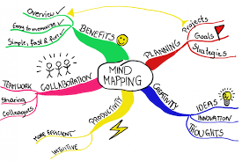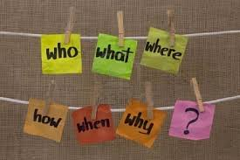

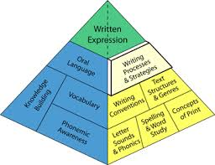**Strategies to support writing**

1. Keep copying from the board to an absolute minimum. If copying is necessary, try alternating the colours of each line to help your learner track their place.
2. Provide sentence starters for your learner.
3. Scaffold writing tasks with mind maps and writing frames such as VCOP pyramids (examples are available in TES resources).
4. Provide spelling lanes, word banks and key word charts. Teach students how to use them.
5. 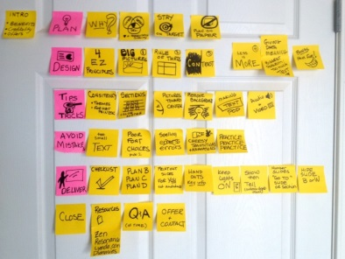Encourage use of mind maps/ post it notes when pupils are planning their piece of writing. Post it notes are great as they can be moved around once the ideas have been noted down.
6. Allow pupils to ‘talk it out’ before writing. Let them talk to a partner about their ideas so they have clarified their thoughts before actually writing.
7. 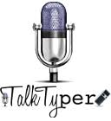Pace writing by determining how much has to be done in a time limit and, if necessary, give motivational feedback.
8. Allow pupils to record their answers using alternative formats (mind maps, video recordings/ spoken recordings).
9. Offer a choice of paper size, shape, colour, lined/ unlined, graph and a range of media. Use pencil grips or alternative pens to improve motor control.
10. [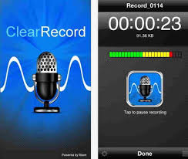](https://www.google.co.uk/imgres?imgurl=http://www.howtoisolve.com/wp-content/uploads/2014/09/6-ClearRecord-Premium-Voice-recorder.jpg&imgrefurl=http://www.howtoisolve.com/the-new-best-voice-recorder-apps-for-iphone-ipad/&docid=QG-T5RO9EPvRzM&tbnid=YANMIlyb_8COeM:&w=662&h=560&safe=strict&bih=754&biw=1440&ved=0ahUKEwjH6ffXiqXNAhVDGx4KHUyVBTwQMwg5KBUwFQ&iact=mrc&uact=8)Use available assistive technology with appropriate students –

* computer or laptop
* free voice recognition such as Siri for ipads, voice recognition in googledocs.
* predictive word processing can help pupils to get started and improve motivation when the work may otherwise feel overwhelming.
* Allow appropriate students to use a scribe on occasions (human/ computer based)

|  |
| --- |
| **Module 6: Reflection on Dyslexia and Writing and Spelling** |

When you have completed the requirements for this module, please reflect on the learning you have undertaken.

|  |
| --- |
| What did I learn that was new to me?  Assessment criteria covered: |
| How do I think it will be useful to me in my practice?  Assessment criteria covered: |

**Module 7**

**AN EXPLORATION OF DYSLEXIA AND MATHS LEARNING DIFFICULTIES**

**Module 7: Dyslexia and Maths Learning Difficulties**

**Please fill in the table below for this module and ensure that you have completed the activities on pages 61 and 62.**

|  |  |  |  |
| --- | --- | --- | --- |
| **Sources of information**  Tick only the sources you have accessed. Please note this does not have to include all of the options below. | | | |
| **Type** | **Details / Content** | **Yes ✓** | **Date accessed** |
| **Attended training session** |  |  |  |
| **Watched video** | **Concrete-Representational-Abstract Instructional Model (3:00)**  <https://www.youtube.com/watch?v=kBsVB141B5c>  An explanation of teaching maths using the concrete-pictorial-abstract method. |  |  |
| **Watched video** | **Teaching Maths to Dyslexic Students – Steve Chinn (1:11:51)**  <https://www.youtube.com/watch?v=JnaBj491rVk&feature=youtb.be>  Strategies to help with math and dyslexia. Dr Steve Chinn uses animations, visuals, and simple patterns to address issues such as math facts, arithmetic, multiplication and division, and more complex topics such as algebra. |  |  |
| **Read text** | **The Elephant in the Classroom** by Jo Boaler, 2009 (available to borrow from DOS)  This book offers concrete suggestions on ways to teach maths well, offering new and more effective ways of learning maths.  **National Numeracy Publication**  <https://www.nationalnumeracy.org.uk/sites/default/files/eitc_character_development_-_updated_branding.pdf>  A short document about why maths is at the heart of ‘character’ development, referencing the work of Jo Boaler’s work *The Elephant in the Classroom* |  |  |
| **Accessed website** | **Jo Boaler**  <https://www.youcubed.org/tasks/>  Hands-on activities to support with the teaching of a range of maths concepts. |  |  |
| **Accessed website** | **Ronit Bird**  <http://www.ronitbird.com/resources/>  Free games as well as teaching videos to support with the teaching of maths. |  |  |
| **Other** |  |  |  |

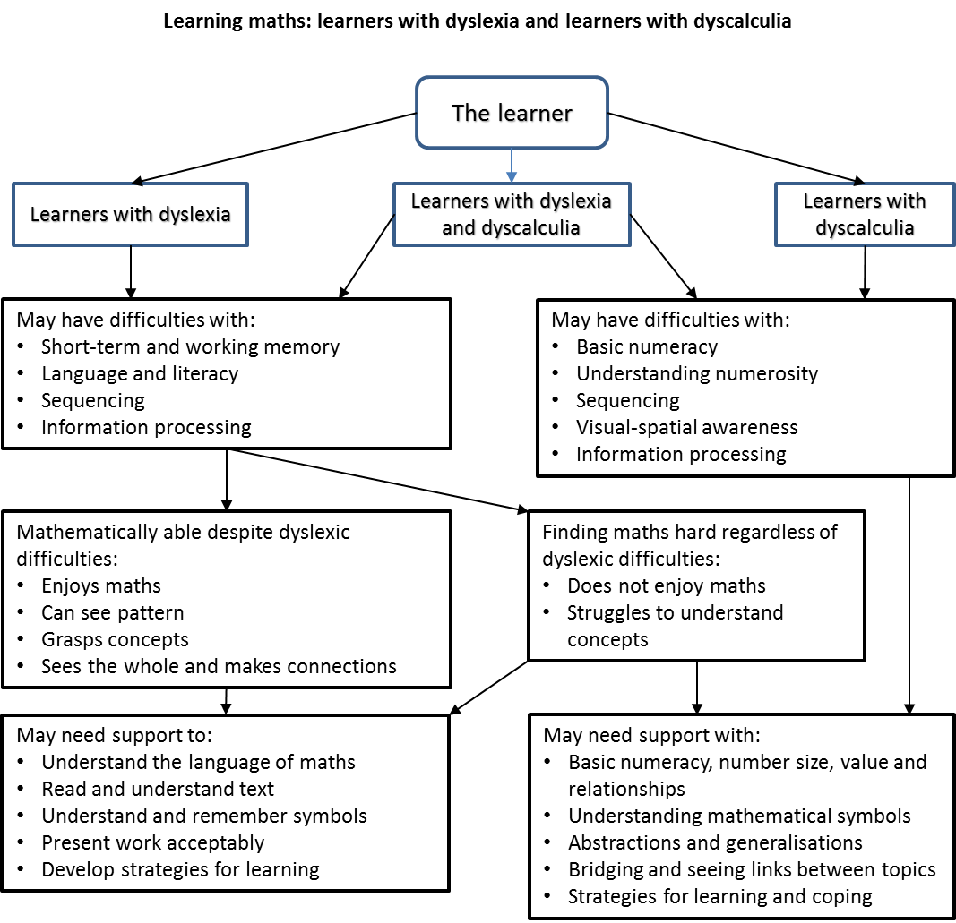

**Assessment criteria: 1.3, 2.1, 3.2, 4.1**

**Select a range of topic areas in maths and explain the different ways dyslexia may impact on them.**

|  |  |  |  |
| --- | --- | --- | --- |
| **Topic area 1:** | | **Topic area 2:** | |
| **Strategy** | | **Strategy** | |
| **Topic area 3:** | Image result for maths cartoon | | **Topic area 4:** |
| **Strategy** | **Strategy** |
| **Topic area 5:** | | **Topic area 6:** | |
| **Strategy** | | **Strategy** | |

|  |
| --- |
| **Module 7: Reflection on Dyslexia and Maths Learning Difficulties** |

When you have completed the requirements for this module, please reflect on the learning you have undertaken.

|  |
| --- |
| What did I learn that was new to me?  Assessment criteria covered: |
| How do I think it will be useful to me in my practice?  Assessment criteria covered: |

**Strategies to support numeracy**

1. Teach strategies:
   * how to use a calculator for basic numeracy
   * how to use squared paper effectively
   * how to use flow charts and colour coding to remember sequences, instructions and where to find information

1. Provide a dyslexia friendly maths kit to include:

* digital clocks
* prompt cards with days of the week, months of the year, mathematical symbols, key vocabulary
* number lines, 100 squares, multiplication squares and other ready reckoners
* egg timers, bead strings

1. Connect things to real life whenever possible to make them relevant.
2. Continually link new concepts explicitly to existing concepts
3. Make things as practical and as visual as possible.
4. Introduce number talks in mixed ability groupings and encourage pupils to try a range of ways of finding an answer rather than just using one method.
5. Make use of manipulatives as often as possible. Ideally move on from the manipulatives to pictorial representations before moving on with abstract maths.

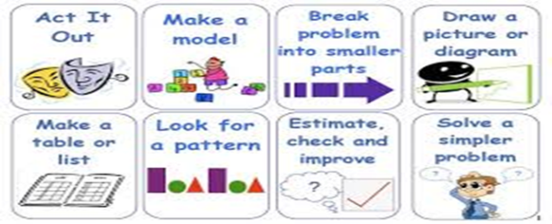

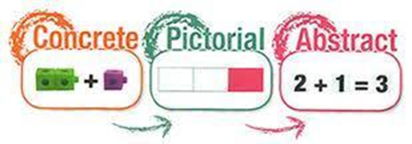

**Module 8**

**AN EXPLORATION OF DYSLEXIA AND ASSESSMENT**

**Module 8: Dyslexia and Assessment**

**Please fill in the table below for this module and ensure that you have completed the activities on pages 67, 70 and 72.**

|  |  |  |  |
| --- | --- | --- | --- |
| **Sources of information**  Tick only the sources you have accessed. Please note this does not have to include all of the options below. | | | |
| **Type** | **Details / Content** | **Yes ✓** | **Date accessed** |
| **Attended training session** |  |  |  |
| **Watched video** | **Inside a dyslexia evaluation (20:43)**  <https://www.youtube.com/watch?v=DNu4WiQaVTI>  A clinical psychologist (USA) evaluates a child for learning and thinking differences. See the dyslexia tests he uses. Hear him explain how these dyslexia tests fit into the overall dyslexia evaluation process. |  |  |
| **Accessed website** | **NHS information**  <https://www.nhs.uk/conditions/dyslexia/diagnosis/>  For parents re: dyslexia diagnosis process |  |  |
| **Accessed website** | **Nessy website**  <https://www.nessy.com/uk/screening-for-dyslexia/>  Information on screening & assessment process and their Dyslexia Quest product |  |  |
| **Accessed website** | **British Dyslexia Association**  <https://www.bdadyslexia.org.uk/dyslexia/how-is-dyslexia-diagnosed>  Information about screening tools, checklists & diagnostic assessments. |  |  |
| **Watched video** | **GL Assessment - Rapid Dyslexia Screener**  <https://www.youtube.com/watch?v=OiCqKmgjZ4s> (5.22)  Information & demo of GL Rapidquick group/class screening for dyslexia in pupils aged 4 to 15.  Three enjoyable and non-threatening subtests cover phonological skills, working memory and phonic decoding. Admin time 15-20 mins. Results give an indication of high/medium/low dyslexic tendencies. |  |  |
| **Watched video** | **GL Assessment - LASS Dyslexia Screener 8-11yrs**  <https://www.youtube.com/watch?v=l27A2qqJFF8> (6.28)  Follow up screener from Rapid (above) for pupils who have a high probability of dyslexia. For ages 8-11 & 11-15. Nine subtests giving a more detailed picture of a pupil’s particular strengths and weaknesses that may impact reading. Admin time 45 mins. |  |  |
| **Other** |  |  |  |

**Assessment criteria: 2.1, 2.2**

**Module 8: Assessment**

**Screening for dyslexia**

A dyslexia screener is an important first stage asset to any SENCO or learning support teacher who has concerns about a pupil. It can play an important part in helping both specialist and non-specialist teachers distinguish between those individuals who are having general difficulties in literacy and those whose difficulties are associated with dyslexia.

Further in depth assessment can then be carried out to focus on particular skills such as spelling and the processing of speech sounds, in order to build up a detailed view of what the person can and cannot currently do, so as to identify the most appropriate form of support for that person.

**Task**

Have a look at the Nessy Dyslexia Quest Screener: <https://www.nessy.com/en-gb/product/dyslexia-quest-home> and the blog ‘What makes a good dyslexia screener?’ <https://www.nessy.com/en-gb/about-us/blog/what-makes-a-good-dyslexia-screener>

In your opinion, what are the pros and cons of computerised screening for dyslexia?

|  |
| --- |
| **Pros** |
| **Cons** |

**Assessment Criteria: 2.1, 2.2**

**Methods of dyslexia assessment**

From your experiences in your own setting, or information gained from attended workshops, list any tests you are aware of that could contribute to an assessment for dyslexia.

|  |  |
| --- | --- |
| **Name of Assessment** | **What it measures** |
|  |  |
|  |  |
|  |  |
|  |  |
|  |  |

**Assessment key terms:**

**Standard score**: This is usually a whole number between 70 and below to 130 and above. Average is between 85 and 115 regardless of which test was used or what age the candidate is.

**Centile (or percentile):** This represents the percentage of children who at the same age would be expected to score at the same level or below. The midpoint is 50 and means that 50 percent of candidates of the same age would attain a score at that level or below. The average range is from the 16th centile to the 84th.

**Bell curve of standard distribution**

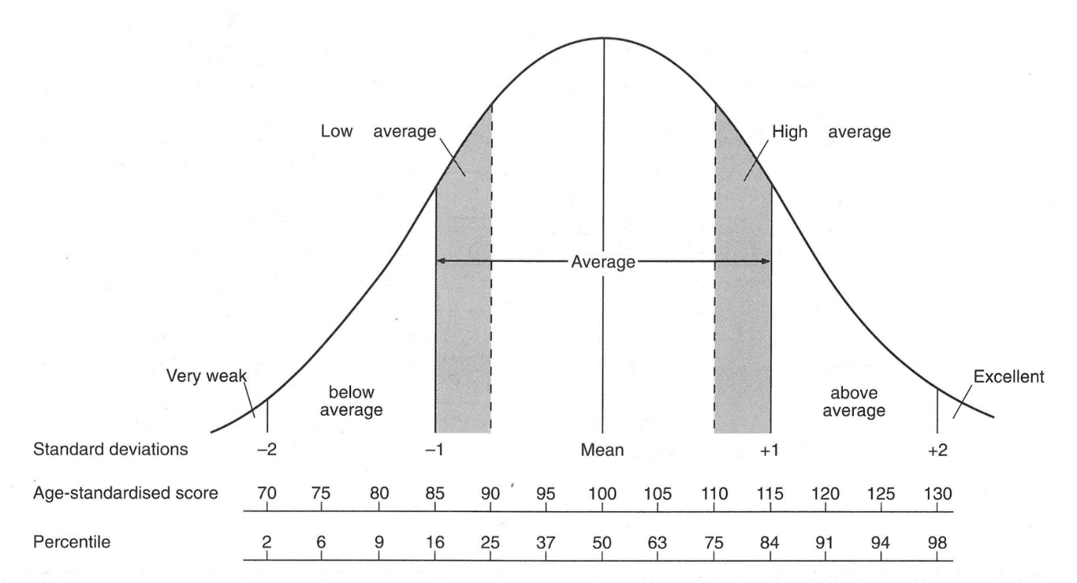

|  |
| --- |
| **Module 8: Reflection on Dyslexia and Assessment** |

When you have completed the requirements for this module, please reflect on the learning you have undertaken.

|  |
| --- |
| What did I learn that was new to me?  Assessment criteria covered: |
| How do I think it will be useful to me in my practice?  Assessment criteria covered: |

**Assessment Criteria: 5.1**

**Independent work**

**Sources of information, advice and guidance related to dyslexia**

Please choose **2** of the websites below to investigate further.

From your chosen websites, please summarise the information available to individuals, their families and those supporting their learning (p72).

|  |
| --- |
| **Information source** |
| The Dyslexia SpLD Trust  <http://www.thedyslexia-spldtrust.org.uk> |
| British Dyslexia Association (BDA)  <http://www.bdadyslexia.org.uk> |
| Helen Arkell Dyslexia Charity  <https://www.helenarkell.org.uk/about-dyslexia.php> |
| Made by Dyslexia  [www.madebydyslexia.org](http://www.madebydyslexia.org) |
| Dyslexia Unwrapped  <https://unwrapped.dyslexiascotland.org.uk/> |
| National Literacy Trust  [www.literacytrust.org.uk](http://www.literacytrust.org.uk) |
| Call Scotland  <https://www.callscotland.org.uk/> |
| Dyslexia Scotland  <https://dyslexiascotland.org.uk/> |

**Independent work**

**Assessment Criteria: 5.1**

**Sources of information, advice and guidance related to dyslexia. (**See previous page for completion guidance)

|  |  |
| --- | --- |
| **Information source**  **Date accessed** | **Details/ Summary** |
|  |  |
|  |  |

**To be completed at the end of the course**

**[](http://www.google.co.uk/imgres?imgurl=http://blog.theecoexperts.co.uk/sites/default/files/main_images/lightbulb.jpg&imgrefurl=http://blog.theecoexperts.co.uk/keep-green-issues-black-and-white&h=360&w=245&tbnid=0wUvIXGdTpXCLM:&zoom=1&q=lightbulb&docid=hJH1WgeRwLO36M&ei=7yMkVPr3AsqUasasgYgD&tbm=isch&ved=0CAwQMygEMAQ4ZA&iact=rc&uact=3&dur=573&page=4&start=100&ndsp=38)Definitions of dyslexia Assessment criteria: 1.1** Finding a definition of dyslexia is simple. Finding one everyone can agree on is challenging. Given your current knowledge and understanding, what do you like and/or dislike about these different definitions? (pages 73 and 74)

|  |
| --- |
| British Psychological Society’s definition:  Dyslexia is evident when accurate and fluent word reading and/or spelling develops very incompletely or with great difficulty. This focuses on literacy learning at the ‘word level’ and implies that the problem is severe and persistent despite appropriate learning opportunities. It provides the basis for a staged process of assessment through teaching. (British Psychological Society, 1999)  A conclusion to the BPS definition as reprinted in 2005 finds that:  ‘Phonological processing continues to be one of the most convincing explanatory elements.  Dyslexia can then be regarded as a function of the reciprocal effects of learning opportunities and the type and extent of phonological and semantic strengths and weaknesses’. |
| Comment |
|  |
| Dyslexia is a specific learning difficulty that affects auditory memory and processing speed which impacts on literacy development, mathematics, memory, organisation and sequencing skills to varying degrees. Dyslexia can occur at any level of intellectual development. It is neurological in origin and is seen to run in families. It affects up to 10% of the UK population at some level and can affect anyone of any age and background.  (Dyslexia SpLD-Trust March 2015) |
| Comment |

|  |
| --- |
| “We would argue that dyslexia is an experience that arises out of natural human diversity on the one hand and a world on the other where the early learning of literacy, and good personal organisation and working memory is mistakenly used as a marker of ‘intelligence’. The problem here is seeing difference incorrectly as ‘deficit’.’’  (Dr Ross Cooper 2006) |
| Comment |
|  |
| 'Dyslexia can be described as a continuum of difficulties in learning to read, write and/or spell, which persist despite the provision of appropriate learning opportunities. These difficulties often do not reflect an individual's cognitive abilities and may not be typical of performance in other areas.  The impact of dyslexia as a barrier to learning varies in degree according to the learning and teaching environment, as there are often associated difficulties such as:   * * auditory and /or visual processing of language-based information * * phonological awareness * * oral language skills and reading fluency * * short-term and working memory * * sequencing and directionality * * number skills * * organisational ability   Dyslexia exists in all cultures and across the range of abilities and socio-economic backgrounds. It is a hereditary, life-long, neurodevelopmental condition.  Learners with dyslexia will benefit from early identification, appropriate intervention and targeted effective teaching, enabling them to become successful learners, confident individuals, effective contributors and responsible citizens.'  (Scottish Government, Dyslexia Scotland, Cross Party Working Group 2009) |
| Comment |

**Definition of Dyslexia - The Rose Report (2009)**

The most commonly adopted definition of dyslexia tends to be that arising from Sir Jim Rose’s independent review into the identifying and teaching of children and young people with dyslexia and literacy difficulties (The Rose Report, 2009). It is stated here for your reference.

|  |
| --- |
| * ‘Dyslexia is a learning difficulty that primarily affects the skills involved in accurate and fluent word reading and spelling. * Characteristic features of dyslexia are difficulties in phonological awareness, verbal memory and verbal processing speed. * Dyslexia occurs across the range of intellectual abilities. * It is best thought of as a continuum, not a distinct category, and there are no clear cut-off points. * Co-occurring difficulties may be seen in aspects of language, motor co-ordination, mental calculation, concentration and personal organisation, but these are not, by themselves, markers of dyslexia. * A good indication of the severity and persistence of dyslexic difficulties can be gained by examining how the individual response or has responded to well-founded intervention.’   (Sir Jim Rose, Identifying and teaching children with dyslexia and literacy difficulties 2009).  The BDA Management Board adopted Sir Jim Rose’s definition with the addition of a further paragraph:  “In addition to these characteristics, the BDA acknowledges the visual processing difficulties that some individuals with dyslexia can experience, and points out that dyslexic readers can show a combination of abilities and difficulties that affect the learning process.  Some also have strengths in other areas, such as design, problem solving, creative skills, interactive skills and oral skills.” |

Updated 07/09/2023 PB/KG/BOB